**Chapter 1: Installing Kubernetes Using Docker**

**Overview**

Kubernetes is software for managing a cluster of Docker containers. Kubernetes orchestration includes scheduling, distributing workload, and scaling. Kubernetes takes the software encapsulation provided by Docker further by introducing Pods. A Pod is a collection of one or more Docker containers with single interface features such as providing networking and filesystem at the Pod level rather than at the container level. Kubernetes also introduces "labels" using which services and replication controllers (replication controller is used to scale a cluster) identify or select the containers or pods they manage. Kubernetes is lightweight, portable (suited for the cloud architecture), and modular.

Kubernetes may be run on almost any platform. Local machine solutions include local Docker based, Vagrant, and no-VM local cluster. Hosted solutions include Google Container Engine. Some of the other platforms supported by Kubernetes are Fedora (Ansible and Manual), Amazon Web Services, Mesos, vSphere, and CoreOS. Kubernetes is an orchestration software for Docker containers; the recommended solution for installation is to use the Docker Engine. In this chapter we shall install Kubernetes on Docker, which runs on Ubuntu. We shall use an Amazon EC2 instance hosting Ubuntu as the operating system. In this chapter, a single node installation of Kubernetes is discussed. Multi-node installation of Kubernetes is discussed in [chapter 14](https://cdn2.percipio.com/1566228253.b35c854e5d30b7b50107168ae58de19049ee01b1/eod/books/113388/OEBPS/chapter-14-133.xhtml#ch0014).

## Setting the Environment

The following software is required for this chapter.

* - Docker Engine (latest version)
* - Kubernetes (version 1.01)

Linux is required to support 64-bit software. We have used an Amazon EC2 instance created from AMI Ubuntu Server 14.04 LTS (HVM), SSD Volume Type - ami-d05e75b8. An Amazon EC2 instance based on the Ubuntu AMI is shown in [Figure 1-1](https://cdn2.percipio.com/1566228253.b35c854e5d30b7b50107168ae58de19049ee01b1/eod/books/113388/OEBPS/section-4.xhtml#ch1_fig1).

Figure 1-1: Amazon EC2 Instance Based on Ubuntu AMI

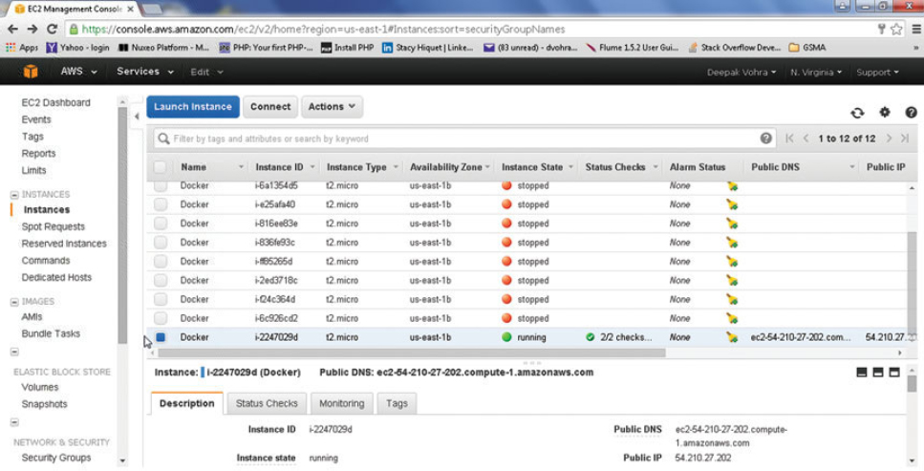

A different Ubuntu version may be used if the requirement of a 64-bit architecture is met. The minimum kernel version requirement is 3.10. The kernel version may be verified with the following command.

uname -r

The Public IP would be different for different users. Multiple Amazon EC2 instances and therefore multiple Public IP addresses have been used in the book as a different Public IP is assigned each time an Amazon EC2 instance is started. The Private IP Address of an Amazon EC2 instance is the same across restarts. SSH into an Ubuntu instance on Amazon EC2 (Public IP is 52.91.80.173 in following command).

ssh -i "docker.pem" ubuntu@52.91.80.173

The Amazon EC2 instance gets logged in as shown in [Figure 1-2](https://cdn2.percipio.com/1566228253.b35c854e5d30b7b50107168ae58de19049ee01b1/eod/books/113388/OEBPS/section-4.xhtml#ch1_fig2). The command prompt becomes "ubuntu@ip-172-30-1-190" instead of root@localhost. Ip 172.30.1.190 is the Private IP of the Amazon EC2 instance and would also be different for different users.

Figure 1-2: Loging into an Amazon EC2 instance

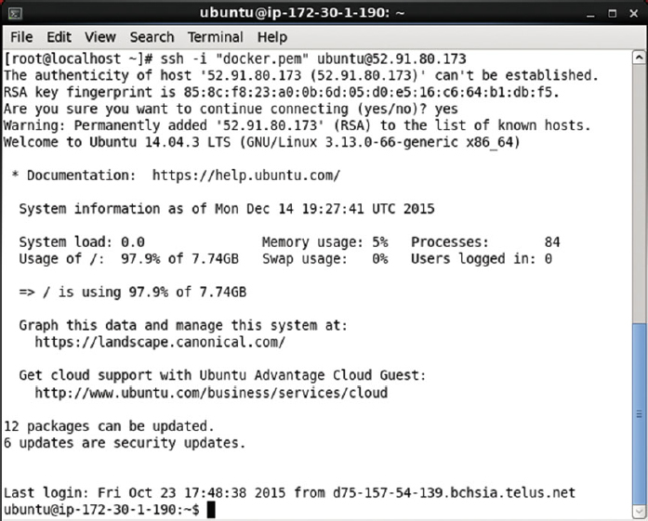

In the next section we shall install Docker on Ubuntu hosted on an Amazon EC2 instance.

**Installing Docker**

Ubuntu uses apt for package management; apt stores a list of repositories in the /etc/apt/sources.list list. Docker's apt repository is kept in the /etc/apt/sources.list.d/docker.list file. First, add the new repository key (gpg key) for the Docker repository with the following command.

sudo apt-key adv --keyserver hkp://pgp.mit.edu:80 --recv-keys

58118E89F3A912897C070ADBF76221572C52609D

The new gpg key gets added as shown in [Figure 1-3](https://cdn2.percipio.com/1566228253.b35c854e5d30b7b50107168ae58de19049ee01b1/eod/books/113388/OEBPS/section-5.xhtml#ch1_fig3).

Figure 1-3: Adding a new gpg key

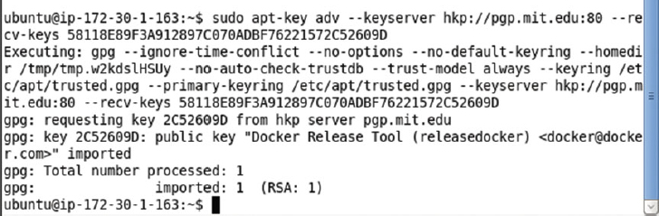

Next, update the apt sources for the Docker repository in the /etc/apt/sources.list.d/docker.list file based on the Ubuntu distribution, which may be found with the following command.

lsb_release –a

For Ubuntu Trusty, add the following line to the /etc/apt/sources.list.d/docker.list file; the docker.list file may be opened with sudo vi /etc/apt/sources.list.d/docker.list.

deb https://apt.dockerproject.org/repo ubuntu-trusty main

Create the /etc/apt/sources.list.d/docker.list file if the file does not already exist. The updated file is shown in [Figure 1-4](https://cdn2.percipio.com/1566228253.b35c854e5d30b7b50107168ae58de19049ee01b1/eod/books/113388/OEBPS/section-5.xhtml#ch1_fig4). Save the file with the :wq command if opened in the vi editor.

Figure 1-4: Creating the docker. list file

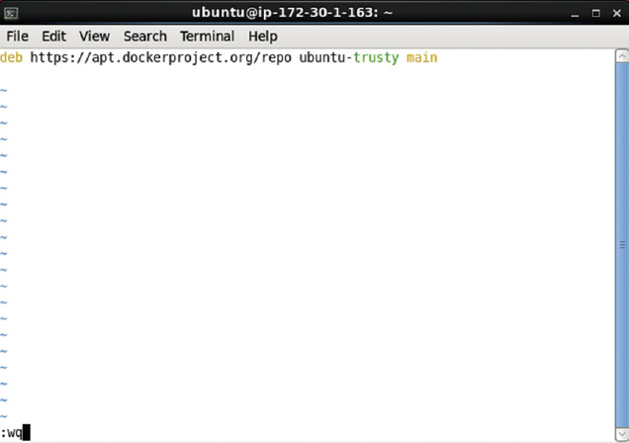

The entry to be added would be different for different Ubuntu distributions as listed in [Table 1-1](https://cdn2.percipio.com/1566228253.b35c854e5d30b7b50107168ae58de19049ee01b1/eod/books/113388/OEBPS/section-5.xhtml#ch1_tab1).

| **Table 1-1: The docker.list file Entry Based on Ubuntu Distribution** | |
| --- | --- |
| **Ubuntu Distribution** | **Entry** |
| Ubuntu Precise 12.04 (LTS) | deb <https://apt.dockerproject.org/repo> ubuntu-precise main |
| Ubuntu Trusty 14.04 (LTS) | deb <https://apt.dockerproject.org/repo> ubuntu-trusty main |
| Ubuntu Vivid 15.04 | deb <https://apt.dockerproject.org/repo> ubuntu-vivid main |

Run the following commands after updating the /etc/apt/sources.list.d/docker.list file to update the apt package index.

sudo apt-get update

Apt package index gets updated as shown in [Figure 1-5](https://cdn2.percipio.com/1566228253.b35c854e5d30b7b50107168ae58de19049ee01b1/eod/books/113388/OEBPS/section-5.xhtml#ch1_fig5).

Figure 1-5: Updating Ubuntu Package List

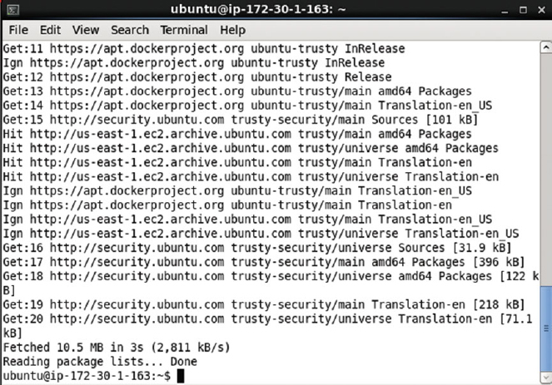

Purge the old repository if it exists with the following command.

sudo apt-get purge lxc-docker*

The output in [Figure 1-6](https://cdn2.percipio.com/1566228253.b35c854e5d30b7b50107168ae58de19049ee01b1/eod/books/113388/OEBPS/section-5.xhtml#ch1_fig6) indicates that the old packages lxc-docker and lxc-docker-virtual-package are not installed and therefore not removed.

Figure 1-6: Purging the Old Repository

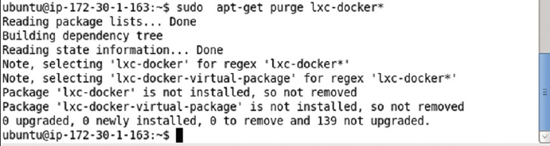

Run the following command to verify that apt is pulling from the updated repository for Docker.

sudo apt-cache policy docker-engine

The output in [Figure 1-7](https://cdn2.percipio.com/1566228253.b35c854e5d30b7b50107168ae58de19049ee01b1/eod/books/113388/OEBPS/section-5.xhtml#ch1_fig7) indicates that the new repository ubuntu-trusty as specified in the /etc/apt/sources.list.d/docker.list is being used.

Figure 1-7: Using the Updated Repository verification

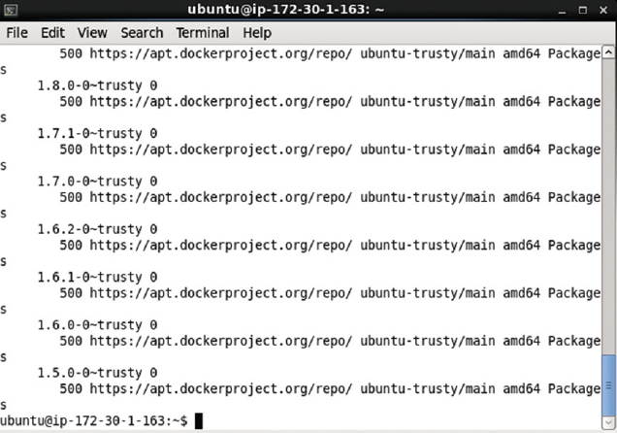

Next, install the prerequisites for Ubuntu, but first update the package manager with the following command.

sudo apt-get update

The package manager gets updated as shown in [Figure 1-8](https://cdn2.percipio.com/1566228253.b35c854e5d30b7b50107168ae58de19049ee01b1/eod/books/113388/OEBPS/section-5.xhtml#ch1_fig8).

Figure 1-8: Updating the Package Manager

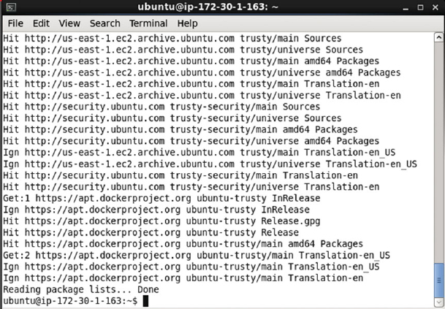

Install the prerequisite linux-image-extra package with the following command.

sudo apt-get install linux-image-generic-lts-trusty

When the preceding command is run, select Y if prompted with the following message.

* *After this operation, 281 MB of additional disk space will be used*.
* *Do you want to continue? [Y/n]*

The message prompt is shown in [Figure 1-9](https://cdn2.percipio.com/1566228253.b35c854e5d30b7b50107168ae58de19049ee01b1/eod/books/113388/OEBPS/section-5.xhtml#ch1_fig9).

Figure 1-9: Message Prompt to Continue

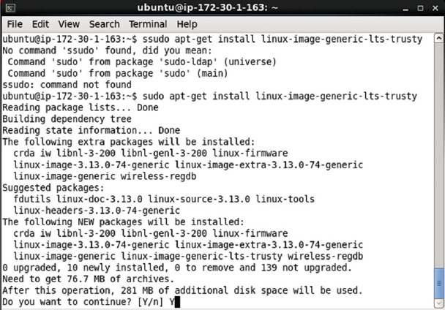

Subsequently, before the command completes, a Package Configuration dialog might prompt with the following message:

*A new version of /boot/grub/menu.lst is available, but the version installed currently has been locally modified. What would you like to do about menu.lst?*

Select the default selection, which is "keep the local version currently installed" and click on Enter as shown in [Figure 1-10](https://cdn2.percipio.com/1566228253.b35c854e5d30b7b50107168ae58de19049ee01b1/eod/books/113388/OEBPS/section-5.xhtml#ch1_fig10).

Figure 1-10: Selecting the Default Package Configuration

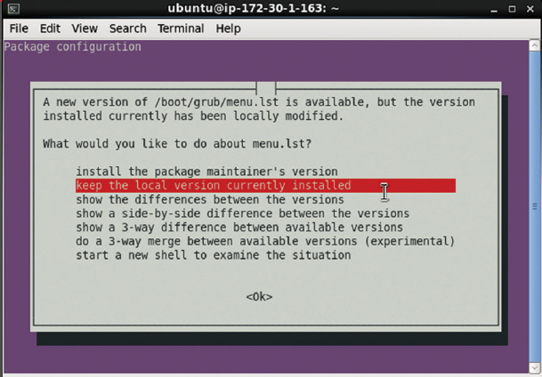

Reboot the system with the following command.

sudo reboot

When the sudo reboot command is run the AmazonEC2 instance is exited. Reconnect with the Amazon EC2 Ubuntu instance with the same ssh command as before.

ssh -i "docker.pem" ubuntu@52.91.80.173

After the host system reboots, update the package manager again with the following command.

sudo apt-get update

Package manager gets updated as shown in [Figure 1-11](https://cdn2.percipio.com/1566228253.b35c854e5d30b7b50107168ae58de19049ee01b1/eod/books/113388/OEBPS/section-5.xhtml#ch1_fig11).

Figure 1-11: Updating Package Manager List after Reboot

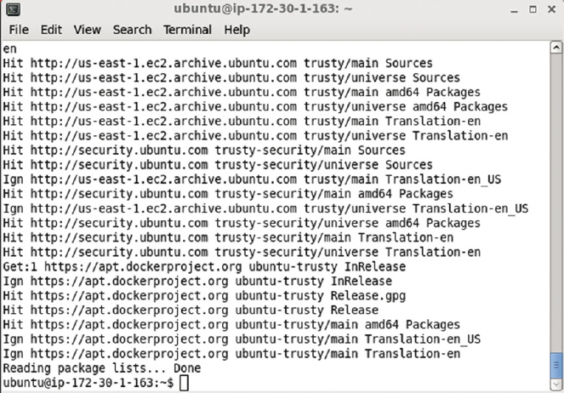

Install Docker with the following command.

sudo apt-get install docker-engine

Select Y at the following prompt, if displayed, as shown in [Figure 1-12](https://cdn2.percipio.com/1566228253.b35c854e5d30b7b50107168ae58de19049ee01b1/eod/books/113388/OEBPS/section-5.xhtml#ch1_fig12).

* *After this operation, 60.3 MB of additional disk space will be used*.
* *Do you want to continue? [Y/n]*

Figure 1-12: Message Prompt about the additional disk space being added

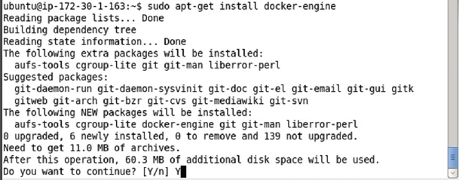

The Docker engine gets installed as shown in [Figure 1-13](https://cdn2.percipio.com/1566228253.b35c854e5d30b7b50107168ae58de19049ee01b1/eod/books/113388/OEBPS/section-5.xhtml#ch1_fig13).

Figure 1-13: Installing the Docker Engine

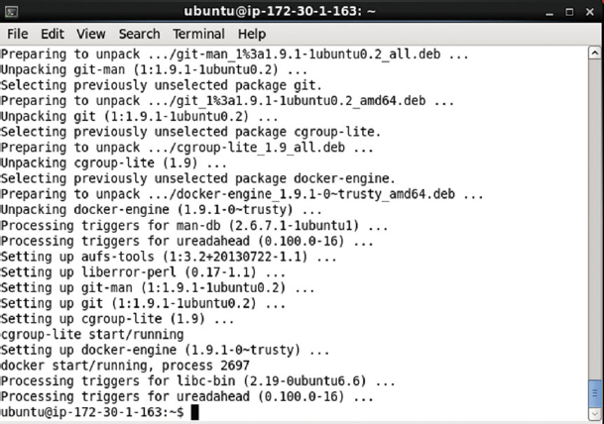

Start the Docker service with the following command.

sudo service docker start

To verify the status of the Docker service, run the following command.

sudo service docker status

The output from the preceding commands is shown in [Figure 1-14](https://cdn2.percipio.com/1566228253.b35c854e5d30b7b50107168ae58de19049ee01b1/eod/books/113388/OEBPS/section-5.xhtml#ch1_fig14). The docker engine is indicated as running as process 2697.

Figure 1-14: Starting Docker and verifying its Status

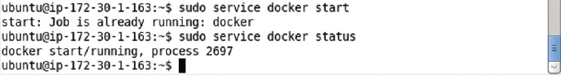

Having installed Docker, next we shall install Kubernetes.

**Installing Kubernetes**

Kubernetes is an open source container cluster manager. The main components of Kubernetes are the following:

1. etcd
2. Kubernetes master
3. Service proxy
4. kubelet

etcd is a simple, secure, fast and reliable distributed key-value store.

Kubernetes master exposes the Kubernetes API using which containers are run on nodes to handle tasks.

kubelet is an agent that runs on each node to monitor the containers running on the node, restarting them if required to keep the replication level.

A service proxy runs on each node to provide the Kubernetes service interface for clients. A service is an abstraction for the logical set of pods represented by the service, and a service selector is used to select the pods represented by the service. The service proxy routes the client traffic to a matching pod. Labels are used to match a service with a pod.

Optionally create a directory (/kubernetes) to install Kubernetes and set its permissions to global (777).

sudo mkdir /kubernetes

sudo chmod -R 777 /kubernetes

The output from the preceding commands is shown in [Figure 1-15](https://cdn2.percipio.com/1566228253.b35c854e5d30b7b50107168ae58de19049ee01b1/eod/books/113388/OEBPS/section-6.xhtml#ch1_fig15).

Figure 1-15: Creating a Directory to install Kubernetes



Change directory to the /kubernetes directory and start the Docker engine.

cd /kubernetes

sudo service docker start

If the Docker Engine is not running, it gets started. The Docker Engine is shown as already running in [Figure 1-16](https://cdn2.percipio.com/1566228253.b35c854e5d30b7b50107168ae58de19049ee01b1/eod/books/113388/OEBPS/section-6.xhtml#ch1_fig16).

Figure 1-16: Starting Docker if not already running

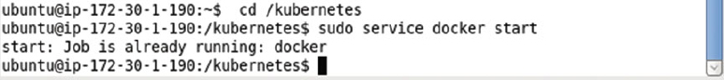

As a prerequisite we need to set some Linux kernel parameters if not already set. Add support for memory and swap accounting. The following configs should be turned on in the kernel.

CONFIG_RESOURCE_COUNTERS=y

CONFIG_MEMCG=y

CONFIG_MEMCG_SWAP=y

CONFIG_MEMCG_SWAP_ENABLED=y

CONFIG_MEMCG_KMEM=y

The kernel configs are enabled when the Ubuntu system boots and the kernel configuration file is in the /boot directory. Change directory (cd) to the /boot directory and list the files/directories.

cd /boot

ls –l

The files in the /boot directory get listed as shown in [Figure 1-17](https://cdn2.percipio.com/1566228253.b35c854e5d30b7b50107168ae58de19049ee01b1/eod/books/113388/OEBPS/section-6.xhtml#ch1_fig17). The kernel configs are configured in the config-3.13.0-48-generic file. The kernel version could be different for different users; for example, the kernel config file could /boot/config-3.13.0-66-generic.

Figure 1-17: Listing the Files in the /boot Directory

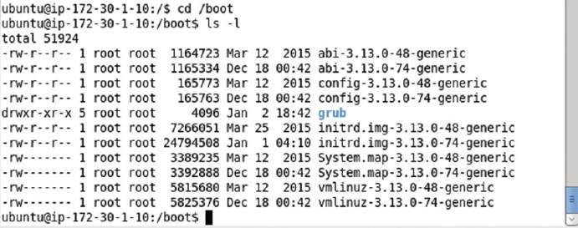

Open the config-3.13.0-48-generic file in a vi editor.

sudo vi /boot/config-3.13.0-48-generic

The kernel configuration parameters get listed as shown in [Figure 1-18](https://cdn2.percipio.com/1566228253.b35c854e5d30b7b50107168ae58de19049ee01b1/eod/books/113388/OEBPS/section-6.xhtml#ch1_fig18).

Figure 1-18: Kernel Configuration Parameter

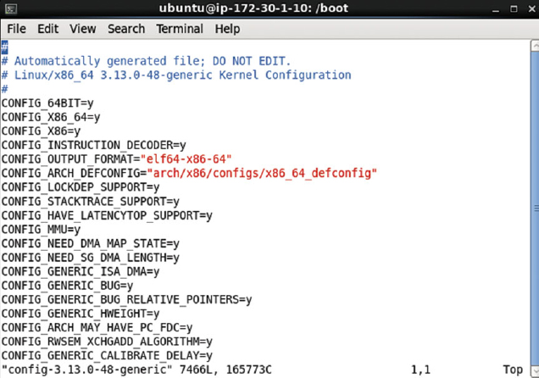

Most of the configs listed earlier are already turned on as shown in [Figure 1-19](https://cdn2.percipio.com/1566228253.b35c854e5d30b7b50107168ae58de19049ee01b1/eod/books/113388/OEBPS/section-6.xhtml#ch1_fig19). The CONFIG_MEMCG_SWAP_ENABLED config is not set.

Figure 1-19: Most of the Required Kernel Parameters are already Set

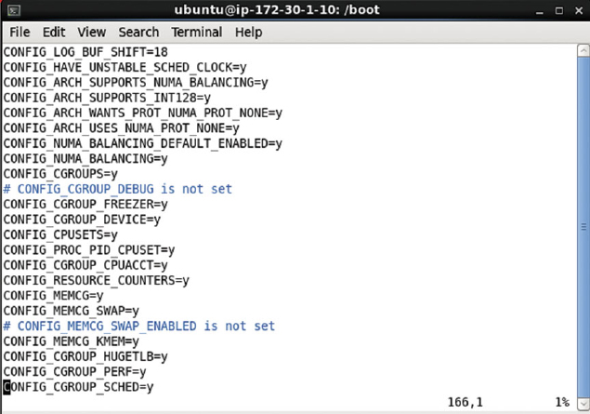

Set CONFIG_MEMCG_SWAP_ENABLED = y and save the kernel configuration file as shown in [Figure 1-20](https://cdn2.percipio.com/1566228253.b35c854e5d30b7b50107168ae58de19049ee01b1/eod/books/113388/OEBPS/section-6.xhtml#ch1_fig20).

Figure 1-20: Setting the CONFIG_MEMCG_SWAP_ENABLED Kernel Parameter

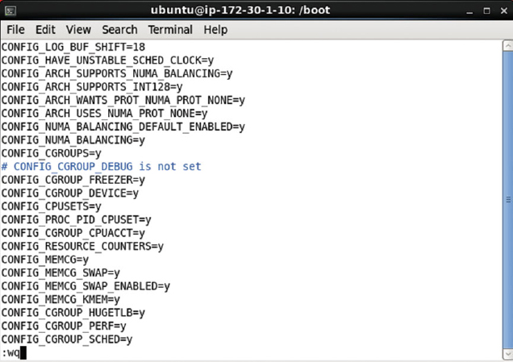

Next, we need to add support for memory and swap accounting to the kernel. The command-line parameters provided to the kernel may be listed with the following command.

cat /proc/cmdline

As shown in [Figure 1-21](https://cdn2.percipio.com/1566228253.b35c854e5d30b7b50107168ae58de19049ee01b1/eod/books/113388/OEBPS/section-6.xhtml#ch1_fig21) memory and swap accounting are not turned on.

Figure 1-21: Listing the Command-Line Parameters

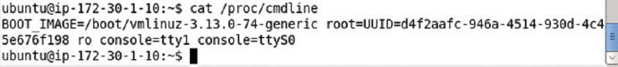

Grub 2 is the default boot loader for Ubuntu. To turn on memory and swap accounting, open the /etc/default/grub file in the vi editor. The GRUB_CMDLINE_LINUX is set to an empty string as shown in [Figure 1-22](https://cdn2.percipio.com/1566228253.b35c854e5d30b7b50107168ae58de19049ee01b1/eod/books/113388/OEBPS/section-6.xhtml#ch1_fig22).

Figure 1-22: The /etc/default/grub file

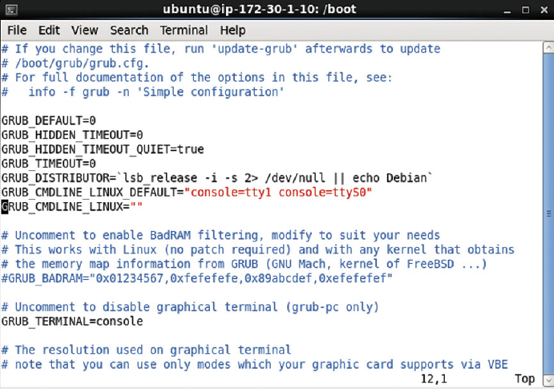

Set the GRUB_CMDLINE_LINU as follows, which enables memory and swap accounting in the kernel at boot.

GRUB_CMDLINE_LINUX="cgroup_enable=memory swapaccount=1"

The modified /etc/default/grub file is shown in [Figure 1-23](https://cdn2.percipio.com/1566228253.b35c854e5d30b7b50107168ae58de19049ee01b1/eod/books/113388/OEBPS/section-6.xhtml#ch1_fig23). Save the file with the :wq command.

Figure 1-23: Modified /etc/default/grub file

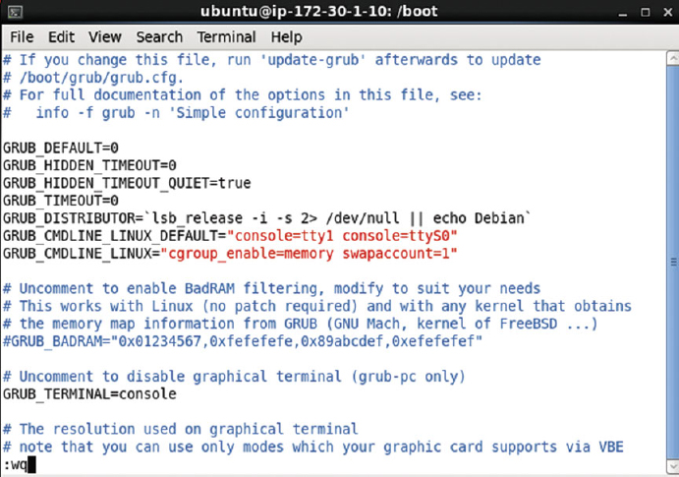

Update the grub.cfg file with the following command.

sudo update-grub

The grub configuration file gets generated as shown in [Figure 1-24](https://cdn2.percipio.com/1566228253.b35c854e5d30b7b50107168ae58de19049ee01b1/eod/books/113388/OEBPS/section-6.xhtml#ch1_fig24).

Figure 1-24: Generating an Updated Grub Configuration file

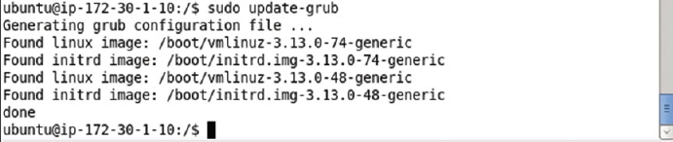

Reboot the system.

sudo reboot

Connection to the Ubuntu Amazon EC2 instance gets closed as shown in [Figure 1-25](https://cdn2.percipio.com/1566228253.b35c854e5d30b7b50107168ae58de19049ee01b1/eod/books/113388/OEBPS/section-6.xhtml#ch1_fig25).

Figure 1-25: Rebooting Ubuntu Instance

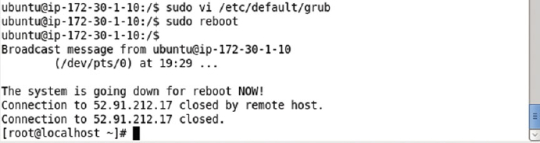

SSH log in back into the Ubuntu instance. Rerun the command to list the command-line kernel parameters.

cat /proc/cmdline

The cgroup_enable = memory swapaccount = 1 settings get output as shown in [Figure 1-26](https://cdn2.percipio.com/1566228253.b35c854e5d30b7b50107168ae58de19049ee01b1/eod/books/113388/OEBPS/section-6.xhtml#ch1_fig26).

Figure 1-26: Updated Settings

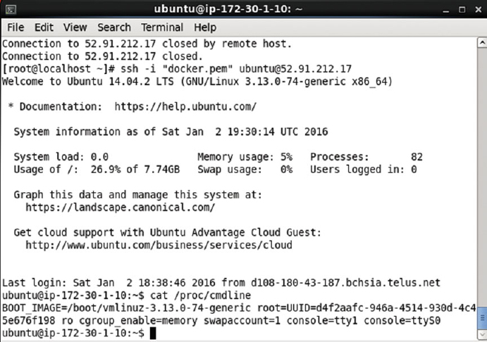

Having set the prerequisite kernel parameters, next we shall start the Kubernetes components etcd, master, and service proxy.

## Starting Kubernetes Master

The Kubernetes master is started using the kubelet, which also starts the other Master components apiserver, scheduler, controller, and pause, which are discussed in [Table 1-3](https://cdn2.percipio.com/1566228253.b35c854e5d30b7b50107168ae58de19049ee01b1/eod/books/113388/OEBPS/section-8.xhtml#ch1_tab3).

| **Table 1-3: The docker run Command Parameters to start etcd** | |
| --- | --- |
| **Master Component** | **Description** |
| Apiserver | The apiserver takes API requests, processes them, and stores the result in etcd if required and returns the result. |
| Scheduler | The scheduler monitors the API for unscheduled pods and schedules them on a node to run and also notifies the about the same to the API. |
| Controller | The controller manages the replication level of the pods, starting new pods in a scale up event and stopping some of the pods in a scale down. |
| Pause | The pause keeps the port mappings of all the containers in the pod or the network endpoint of the pod. |

Run the Kubernetes master with the following command.

sudo docker run \

--volume=/:/rootfs:ro \

--volume=/sys:/sys:ro \

--volume=/dev:/dev \

--volume=/var/lib/docker/:/var/lib/docker:ro \

--volume=/var/lib/kubelet/:/var/lib/kubelet:rw \

--volume=/var/run:/var/run:rw \

--net=host \

--pid=host \

--privileged=true \

-d \

gcr.io/google_containers/hyperkube:v1.0.1 \

/hyperkube kubelet --containerized --hostname-override="127.0.0.1"

--address="0.0.0.0" --api-

servers=http://localhost:8080 --config=/etc/kubernetes/manifests

The docker run command parameters are discussed in [Table 1-4](https://cdn2.percipio.com/1566228253.b35c854e5d30b7b50107168ae58de19049ee01b1/eod/books/113388/OEBPS/section-8.xhtml#ch1_tab4).

| **Table 1-4: The docker run Command Parameters to start etcd** | |
| --- | --- |
| **Parameter** | **Description** |
| --volume=/:/rootfs:ro \  --volume=/sys:/sys:ro \  --volume=/dev:/dev \  --volume=/var/lib/docker/:/var/lib/docker:ro \  --volume=/var/lib/kubelet/:/var/lib/kubelet:rw \  --volume=/var/run:/var/run:rw \ | The Docker volumes to use |
| --net=host | Connects the Docker container to a network making use of the host container network inside the container |
| --pid=host | Sets the pid namespace |
| --privileged = true | Provides access to most of the capabilities of the host machine in terms of kernel features and host access |
| -d | Starts the container in the background |
| gcr.io/google_containers/hyperkube:v1.0.1 | The container image |
| hyperkube kubelet  --containerized  --hostname-override= "127.0.0.1"  --address="0.0.0.0"  --api-  servers=http://localhost:8080  --config=/etc/kubernetes/manifests | The command run |

The output from the docker run command to start the master is shown in [Figure 1-29](https://cdn2.percipio.com/1566228253.b35c854e5d30b7b50107168ae58de19049ee01b1/eod/books/113388/OEBPS/section-8.xhtml#ch1_fig29).

Figure 1-29: The docker run Command to start Kubernetes Master

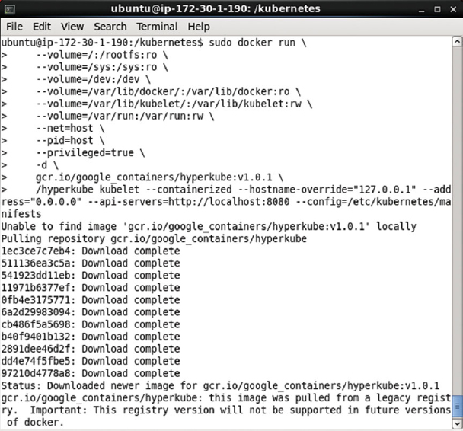

The Master is required to be started each time the Kubernetes cluster manager is to be started. The container image is downloaded only the first time the command is run, and on subsequent runs the image is not downloaded as shown in [Figure 1-30](https://cdn2.percipio.com/1566228253.b35c854e5d30b7b50107168ae58de19049ee01b1/eod/books/113388/OEBPS/section-8.xhtml#ch1_fig30).

Figure 1-30: Subsequent starts of Kubernetes Master do not need to download Container image again

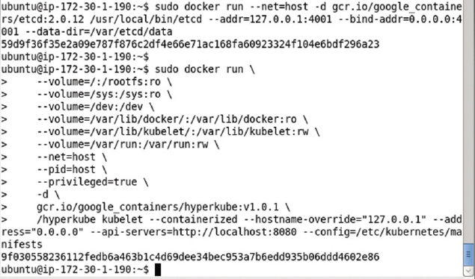

## Starting Service Proxy

To start the service proxy, which is a proxy for the Kubernetes service providing a pod/s interface using a service selector with labels, start the service proxy by running the following docker run command.

sudo docker run -d --net=host --privileged gcr.io/google_containers/hyperkube:v1.0.1

/hyperkube proxy -- master=http://127.0.0.1:8080 --v=2

The command parameters for the preceding command are discussed in [Table 1-5](https://cdn2.percipio.com/1566228253.b35c854e5d30b7b50107168ae58de19049ee01b1/eod/books/113388/OEBPS/section-9.xhtml#ch1_tab5).

| **Table 1-5: The docker run Command Parameters to start service proxy** | |
| --- | --- |
| **Parameter** | **Description** |
| -d | Runs the container in the background |
| --net=host | Sets the network for the container to the host's network |
| -- privileged | Provides access to most of the capabilities of the host machine in terms of kernel features and host access |
| gcr.io/google_containers/hyperkube:v1.0.1 | The container image |
| hyperkube proxy -- master=  http://127.0.0.1:8080 --v=2 | The command to run. The master url is set to [http://127.0.0.1:8080](http://127.0.0.1:8080/). |

The output from the preceding docker run command is shown in [Figure 1-31](https://cdn2.percipio.com/1566228253.b35c854e5d30b7b50107168ae58de19049ee01b1/eod/books/113388/OEBPS/section-9.xhtml#ch1_fig31).

Figure 1-31: Starting the Service proxy

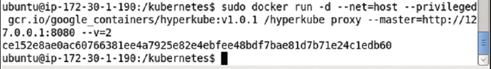

## Listing the Kubernetes Docker Containers

The Docker containers started for a Kubernetes cluster manager may be listed with the following command.

sudo docker ps

The Docker containers listed include a container for the service proxy; a container for the kubelet; a container for etcd; and containers each for the master scheduler, controller, and apiserver, and pause as shown in [Figure 1-32](https://cdn2.percipio.com/1566228253.b35c854e5d30b7b50107168ae58de19049ee01b1/eod/books/113388/OEBPS/section-10.xhtml#ch1_fig32).

Figure 1-32: Listing the Docker Containers

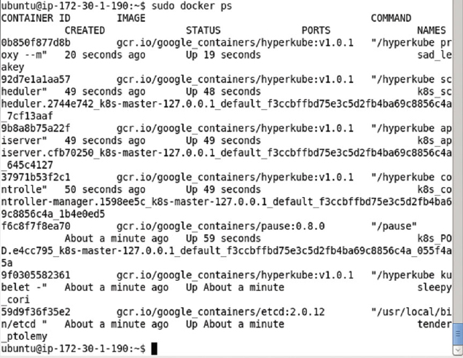

The Docker container info may be found using the Docker container id. For example, obtain the container id for the Docker container running the controller as shown in [Figure 1-33](https://cdn2.percipio.com/1566228253.b35c854e5d30b7b50107168ae58de19049ee01b1/eod/books/113388/OEBPS/section-10.xhtml#ch1_fig33).

Figure 1-33: Obtaining the Docker Container Id

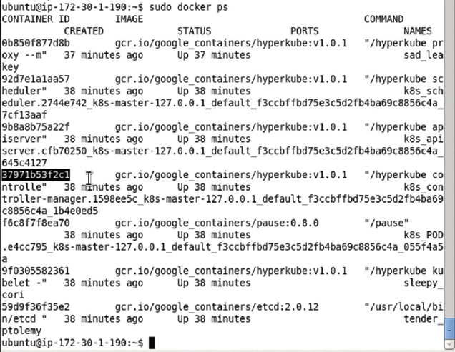

Run the following command to find the detail about the Docker container.

sudo docker inspect 37971b53f2c1

The detail such as the master ip and about the Docker container running the controller manager gets output as shown in [Figure 1-34](https://cdn2.percipio.com/1566228253.b35c854e5d30b7b50107168ae58de19049ee01b1/eod/books/113388/OEBPS/section-10.xhtml#ch1_fig34).

Figure 1-34: Listing Docker Container Information

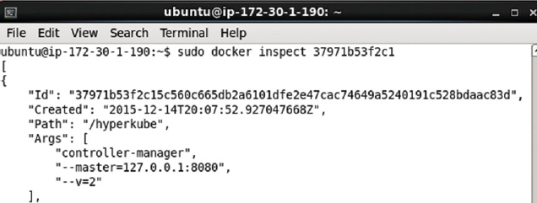

## Installing kubectl

The kubectl is used to control the Kubernetes cluster manager including running an image, getting the pods, getting the replication controller, making an application available as a service exposed at a specified port, and scaling the cluster. Download Kubectl binaries with the following command.

sudo wget https://storage.googleapis.com/kubernetes-release/release/v1.0.1/bin/linux/amd64/kubectl

The kubectl binaries get downloaded as shown in [Figure 1-35](https://cdn2.percipio.com/1566228253.b35c854e5d30b7b50107168ae58de19049ee01b1/eod/books/113388/OEBPS/section-11.xhtml#ch1_fig35).

Figure 1-35: Installing Kubectl

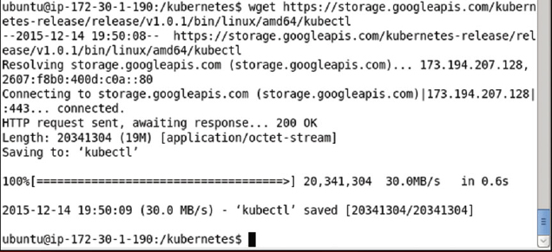

Make the kubectl application executable by applying the + x permissions.

sudo chmod +x kubectl

Move the kubectl binaries to the /usr/local/bin/ directory.

sudo mv kubectl /usr/local/bin/

The output from the preceding commands is shown in [Figure 1-36](https://cdn2.percipio.com/1566228253.b35c854e5d30b7b50107168ae58de19049ee01b1/eod/books/113388/OEBPS/section-11.xhtml#ch1_fig36).

Figure 1-36: Moving and making kubectl Binaries executable



The kubectl command lists the usage as shown in [Figure 1-37](https://cdn2.percipio.com/1566228253.b35c854e5d30b7b50107168ae58de19049ee01b1/eod/books/113388/OEBPS/section-11.xhtml#ch1_fig37).

Figure 1-37: Kubectl Command Usage

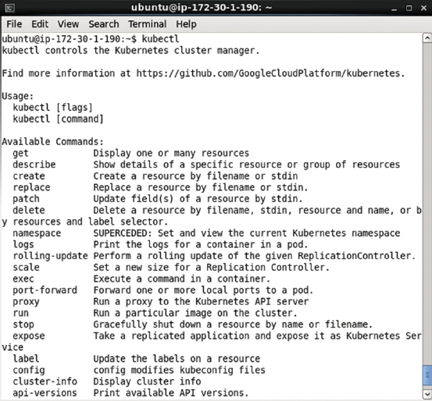

The command parameters also get listed as shown in [Figure 1-38](https://cdn2.percipio.com/1566228253.b35c854e5d30b7b50107168ae58de19049ee01b1/eod/books/113388/OEBPS/section-11.xhtml#ch1_fig38).

Figure 1-38: Command Parameters for Kubectl

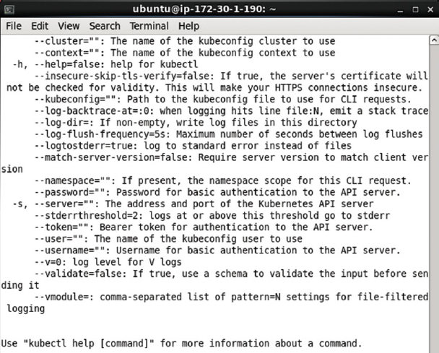

## Listing Services

The following command should list the Kubernetes service.

kubectl get services

The kubernetes service gets listed as shown in [Figure 1-39](https://cdn2.percipio.com/1566228253.b35c854e5d30b7b50107168ae58de19049ee01b1/eod/books/113388/OEBPS/section-12.xhtml#ch1_fig39).

Figure 1-39: Listing the Kubernetes Service

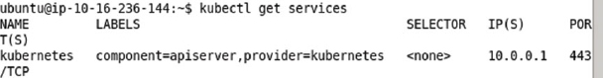

## Listing Nodes

The following command should list the Kubernetes node.

kubectl get nodes

The single node in the cluster gets listed as shown in [Figure 1-40](https://cdn2.percipio.com/1566228253.b35c854e5d30b7b50107168ae58de19049ee01b1/eod/books/113388/OEBPS/section-13.xhtml#ch1_fig40).

Figure 1-40: Listing the Nodes

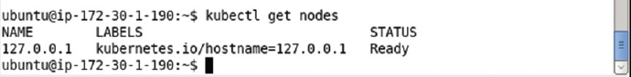

## Testing the Kubernetes Installation

To test the Kubernetes cluster manager, run the nginx application using the following command.

kubectl -s http://localhost:8080 run nginx --image=nginx --port=80

The output from the kubectl run command lists the replication controller, container/s, image/sm selector, and replicas as shown in [Figure 1-41](https://cdn2.percipio.com/1566228253.b35c854e5d30b7b50107168ae58de19049ee01b1/eod/books/113388/OEBPS/section-14.xhtml#ch1_fig41).

Figure 1-41: Running he nginx Application on Kubernetes Cluster

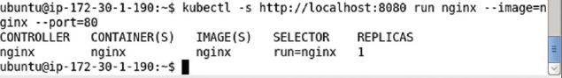

Expose the nginx application replication controller as a service with the kubectl expose command.

kubectl expose rc nginx --port=80

The nginx Kubernetes service gets created running on port 80 as shown in [Figure 1-42](https://cdn2.percipio.com/1566228253.b35c854e5d30b7b50107168ae58de19049ee01b1/eod/books/113388/OEBPS/section-14.xhtml#ch1_fig42).

Figure 1-42: Creating a Kubernetes Service for nginx Application

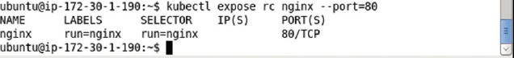

List the detail about the nginx service with the kubectl get svc command.

kubectl get svc nginx

The nginx service detail gets listed as shown in [Figure 1-43](https://cdn2.percipio.com/1566228253.b35c854e5d30b7b50107168ae58de19049ee01b1/eod/books/113388/OEBPS/section-14.xhtml#ch1_fig43).

Figure 1-43: Listing the Kubernetes Service nginx

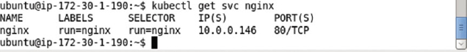

The cluster IP may be obtained with the following command.

kubectl get svc nginx --template={{.spec.clusterIP}}

The cluster ip is listed as 10.0.0.146 as shown in [Figure 1-44](https://cdn2.percipio.com/1566228253.b35c854e5d30b7b50107168ae58de19049ee01b1/eod/books/113388/OEBPS/section-14.xhtml#ch1_fig44).

Figure 1-44: Listing the Cluster IP



The web server may be called making use of the cluster ip with the following command.

curl 10.0.0.146

The html output as text gets output as shown in [Figure 1-45](https://cdn2.percipio.com/1566228253.b35c854e5d30b7b50107168ae58de19049ee01b1/eod/books/113388/OEBPS/section-14.xhtml#ch1_fig45).

Figure 1-45: Using curl to invoke Application

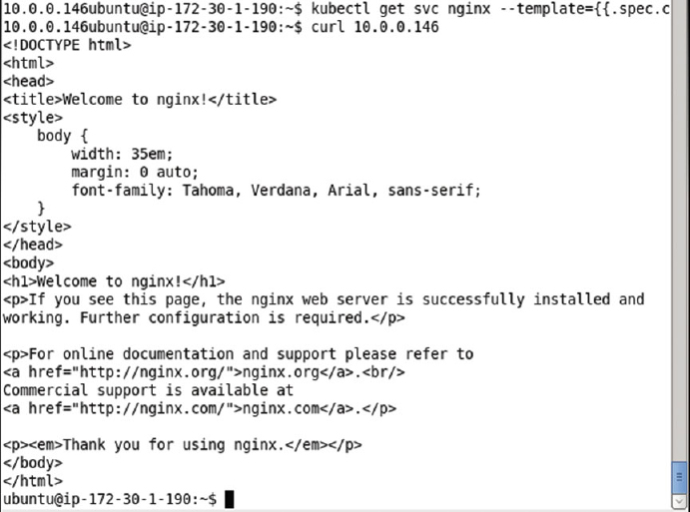

## Chapter 2: Hello Kubernetes

**© Deepak Vohra 2016  
D. Vohra, Kubernetes Microservices with Docker, DOI 10.1007/978-1-4842-1907-2_2**

### Overview

Kubernetes is a cluster manager for Linux containers. While Kubernetes supports other types of containers such as Rocket, and support for more types is to be added, we shall discuss Kubernetes in the context of Docker containers only. Docker is an open source container virtualization platform to build, package, and run distributed applications in containers that are lightweight snapshots of the underlying OS. A Docker image, which is application specific, encapsulates all the required software including dependencies for an application and is used to create Docker containers to run applications in the containers. The Docker containers are isolated from each other and have their own networking and filesystem and provide Container as a Service (CaaS). Docker is similar to virtual machines based on virtualization platforms such as Oracle VirtualBox and VMWare Player in that it is a virtualization over the underlying OS, but is different in that while a virtual machine makes use of an entire operating system, multiple Docker containers share the kernel and run in isolation on the host OS. Docker containers run on the Docker Engine, which runs on the underlying OS kernel.

In this chapter we shall introduce Kubernetes concepts using a Hello-World application.

Kubernetes concepts include Pod, Service, and Replication controller and are defined in the following subsections.

#### What Is a Node?

A node is a machine (physical or virtual) running Kubernetes onto which Pods may be scheduled. The node could be the master node or one of the worker nodes. In the preceding chapter on installing Kubernetes only a single node was used. In a later chapter, [Chapter 14](https://cdn2.percipio.com/1566228253.b35c854e5d30b7b50107168ae58de19049ee01b1/eod/books/113388/OEBPS/chapter-14-133.xhtml#ch0014), we shall discuss creating a multi-node clusterwith a master and worker node/s.

#### What Is a Cluster?

A cluster is a collection of nodes including other resources such as storage to run Kubernetes applications. A cluster has a single Kubernetes master node and zero or more worker nodes. A highly available cluster consists of multiple masters or master nodes.

#### What Is a Pod?

A Pod is a collection of containers that are collocated and form an atomic unit. Multiple applications may be run within a Pod and though the different containers within a Pod could be for the same application, typically the different containers are for different applications. A Pod is a higher level abstraction for managing a group of containers with shared volumes and network namespace. All the applications (containers) in a Pod share the same filesystem and IP address with the port on which each application is exposed being different. Applications running in a Pod may access each other at "localhost" Scheduling and replication are performed at the Pod level rather than at the individual container level. For example if a Pod defines two containers for different applications and replication level is set at 1, a single replica of the Pod consists of two containers, one each for the two applications. Pods facilitate resource sharing and communication what would otherwise be implemented using --link in individually running Docker containers. A Pod consisting of multiple containers would typically be used for tightly coupled applications. For example, if an nginx application makes use of MySQL database, the two applications are able to interact by Kubernetes running containers for each in the same Pod.

#### What Is a Service?

A Service is the external interface for one or more Pods providing endpoint/s at which the application/s represented by the Service may be invoked. A Service is hosted at a single IP address but provides zero or more endpoints depending on the application/s interfaced by the Service. Services are connected to Pods using label selectors. Pods have label/s on them and a Service with a selector expression the same as a Pod label represents the Pod to an external client. An external client does not know or need to know about the Pods represented by a Service. An external client only needs to know the name of the Service and the port at which a particular application is exposed. The Service routes requests for an application based on a round-robin manner to one of the Pods selected using a label selector/. Thus, a Service is a high level abstraction for a collection of applications leaving the detail of which Pod to route a request to up to the Service. A Service could also be used for load balancing.

#### What Is a Replication Controller?

A Replication Controller manages the replication level of Pods as specified by the "replicas" setting in a Replication Controller definition or on the command line with the -replicas parameter. A Replication Controller ensures that the configured level of Pod replicas are running at any given time. If a replica fails or is stopped deliberately a new replica is started automatically. A Replication Controller is used for scaling the Pods within a cluster. A replica is defined at the Pod level implying that if a Pod consists of two containers a group of the two configured containers constitute a replica.

#### What Is a Label?

A Label is a key-value pair identifying a resource such as a Pod, Service, or Replication Controller: most commonly a Pod. Labels are used to identify a group or subset of resources for tasks such as assigning them to a Service. Services use label selectors to select the Pods they manage. For example, if a Pod is labeled "app = helloApp" and a Service "selector" is set as "app = helloApp" the Pod is represented by the Service. Service selectors are based on labels and not on the type of application they manage. For example, a Service could be representing a Pod running a hello-world application container with a specific label. Another Pod also running a hello-world container but with a label different than the Service selector expression would not be represented by the Service. And a third Pod running an application that is not a hello-world application but has the same label as the Service selector would also be represented by the same Service.

#### What Is a Selector?

A selector is a key-value expression to identify resources using matching labels. As discussed in the preceding subsection a Service selector expression "app = helloApp" would select all Pods with the label "app = helloApp". While typically a Service defines a selector to select Pods a Service could be defined to not include a selector and be defined to abstract other kinds of back ends. Two kinds of selectors are supported: equality-based and set-based. A selector could be made of multiple requirements implying that multiple expressions (equality-based or set-based) separated by ',' could be specified. All of the requirements must be met by a matching resource such as a Pod for the resource to be selected. A resource such as a Pod could have additional labels, but the ones in the selector must be specified for the resource to be selected. The equality-based selector, which is more commonly used and also the one used in the book, supports =,!=,== operators, the = being synonymous to ==.

#### What Is a Name?

A name is identifies a resource. A name is not the same as a label. For matching resources with a Service a label is used and not a name.

#### What Is a Namespace?

A namespace is a level above the name to demarcate a group of resources for a project or team to prevent name collisions. Resources within different namespaces could have the same name, but resources within a namespace have different names.

#### What Is a Volume?

A volume is a directory within the filesystem of a container. A volume could be used to store data. Kubernetes volumes evolve from Docker volumes.

#### Why Kubernetes?

Docker containers introduced a new level of modularity and fluidity for applications with the provision to package applications including dependencies, and transfer and run the applications across different environments. But with the use of Docker containers in production, practical problems became apparent such as which container to run on which node (scheduling), how to increase/decrease the number of running containers for an application (scaling), and how to communicate within containers. Kubernetes was designed to overcome all these and other practical issues of container cluster management. Kubernetes provides dynamic container cluster orchestration in real time. Kubernetes as a cluster manager provides the following benefits.

* -Microservices by breaking an application into smaller, manageable, scalable components that could be used by groups with different requirements.
* -Fault-tolerant cluster in which if a single Pod replica fails (due to node failure, for example), another is started automatically.
* -Horizontal scaling in which additional or fewer replicas of a Pod could be run by just modifying the "replicas" setting in the Replication Controller or using the -replicas parameter in the kubectl scale command.
* -Higher resource utilization and efficiency.
* -Separation of concerns. The Service development team does not need to interface with the cluster infrastructure team.

**Setting the Environment**

The following software is required for this chapter.

* -Docker Engine (latest version)
* -Kubernetes (version 1.01)
* -Kubectl (version 1.01)

We have used an Amazon EC2 Linux instance created from AMI Ubuntu Server 14.04 LTS (HVM), SSD Volume Type - ami-d05e75b8.

SSH Login to the Ubuntu interface (Public IP address would be different for different users and multiple IP Addresses may have been used in this chapter).

ssh -i "docker.pem" ubuntu@54.152.82.142

Install Docker as discussed in [Chapter 1](https://cdn2.percipio.com/1566228253.b35c854e5d30b7b50107168ae58de19049ee01b1/eod/books/113388/OEBPS/chapter-1-3.xhtml#ch001) and start the Docker Engine and verify its status using the following commands.

sudo service docker start

sudo service docker status

Install kubectl and start the Kubernetes cluster manager as discussed in [Chapter 1](https://cdn2.percipio.com/1566228253.b35c854e5d30b7b50107168ae58de19049ee01b1/eod/books/113388/OEBPS/chapter-1-3.xhtml#ch001). Output the Kubernetes cluster information using the following command.

kubectl cluster-info

The Kubernetes Master is shown running on [http://localhost:8080](http://localhost:8080/) in [Figure 2-1](https://cdn2.percipio.com/1566228253.b35c854e5d30b7b50107168ae58de19049ee01b1/eod/books/113388/OEBPS/section-17.xhtml#ch2_fig1).

Figure 2-1: Getting Cluster Info



In the following sections we shall run a hello-world application using the Kubernetes cluster manager. An application may be run imperatively using the kubectl tool on the command line or declaratively using definition files for a Pod, Replication Controller, and Service. We shall discuss each of these methods. The kubectl tool is used throughout this chapter and in subsequent chapters and a complete command reference is available at <https://cloud.google.com/container-engine/docs/kubectl/>.

## Creating an Application Imperatively

With the Kubernetes master running on [http://localhost:8080](http://localhost:8080/), as obtained in the preceding section, run the following kubectl run command to run a hello-world application using the image tutum/hello-world. The –s option specifies the Kubernetes API server host and port. The –image command parameter specifies the Docker image to run as tutum/hello-world. The –replicasparameter specifies the number of replicas to create as 1. A Replication Controller is created even if the –replicas parameter is not specified. The default number of replicas is 1. The –portparameter specifies the container port the application is hosted at as 80.

kubectl -s http://localhost:8080 run hello-world --image=tutum/hello-world --replicas=1 --port=80

A new application container called hello-world gets created as shown in [Figure 2-2](https://cdn2.percipio.com/1566228253.b35c854e5d30b7b50107168ae58de19049ee01b1/eod/books/113388/OEBPS/section-18.xhtml#ch2_fig2). A Replication Controller called "hello-world" also gets created. The Pod is created implicitly and label "run = hello-world" is added to the Pod. The number of replicas created is 1. The Replication Controller's selector field is also set to "run=hello-world" The Pods managed by a Replication Controller must specify a label that is the same as the selector specified at the Replication Controller level. By default a Replication Controller selector is set to the same expression as the Pod label.

Figure 2-2: Creating an Application including a Replication Controller and Pod Replica/s

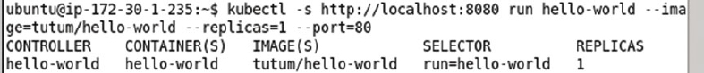

The Replication Controller created may be listed with the following command.

kubectl get rc

The hello-world Replication Controller gets listed as shown in [Figure 2-3](https://cdn2.percipio.com/1566228253.b35c854e5d30b7b50107168ae58de19049ee01b1/eod/books/113388/OEBPS/section-18.xhtml#ch2_fig3).

Figure 2-3: Listing the Replication Controllers



The Pods created and started are listed with the following command.

kubectl get pods

The single Pod created gets listed as shown in [Figure 2-4](https://cdn2.percipio.com/1566228253.b35c854e5d30b7b50107168ae58de19049ee01b1/eod/books/113388/OEBPS/section-18.xhtml#ch2_fig4). A Pod name is assigned automatically. A Pod STATUS "Running" is listed, but the Pod may still not be ready and available. The READY column value of 0/1 indicates that 0 of 1 containers in the Pod are ready, which implies that the Pod has been created and is running but not yet ready. It could take a few seconds for a Pod to become Ready.

Figure 2-4: Listing the Pods

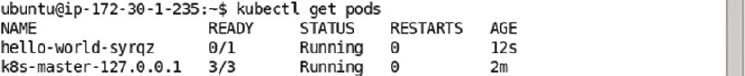

Run the same command again after a few seconds or a minute.

kubectl get pods

The Pod gets listed as ready as indicated by 1/1 in the READY column in [Figure 2-5](https://cdn2.percipio.com/1566228253.b35c854e5d30b7b50107168ae58de19049ee01b1/eod/books/113388/OEBPS/section-18.xhtml#ch2_fig5). A value of 1/1 in the READY column indicates that 1 of 1 containers in the Pod are ready. The syntax for the READY column value is nReady/nTotal, which implies that nReady of the total nTotal containers in the Pod are ready. The Kubernetes Pod k8s-master-127.0.0.1, for example, has a READY column value of 3/3, which implies that 3 of 3 containers in the Kubernetes Pod are ready.

Figure 2-5: Listing a Pod as ready with all containers in the Pod as ready

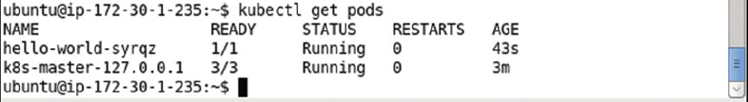

Running a Pod and a Replication Controller does not implicitly create a Service. In the next subsection we shall create a Service for the hello-world application.

### Creating a Service

Create a Kubernetes Service using the kubectl expose command, which creates a Service from a Pod, Replication Controller, or another Service. As we created a Replication Controller called hello-world, create a Service using the following command in which the port to expose the Service is set to 8080 and the Service type is LoadBalancer.

kubectl expose rc hello-world --port=8080 --type=LoadBalancer

A Kubernetes Service called hello-world gets created as shown in [Figure 2-6](https://cdn2.percipio.com/1566228253.b35c854e5d30b7b50107168ae58de19049ee01b1/eod/books/113388/OEBPS/section-18.xhtml#ch2_fig6). The Service labels and selector also get set. The Service selector, listed in [Figure 2-6](https://cdn2.percipio.com/1566228253.b35c854e5d30b7b50107168ae58de19049ee01b1/eod/books/113388/OEBPS/section-18.xhtml#ch2_fig6), is set to the same expression run=hello-world as the Replication Controller selector, which is shown in [Figure 2-3](https://cdn2.percipio.com/1566228253.b35c854e5d30b7b50107168ae58de19049ee01b1/eod/books/113388/OEBPS/section-18.xhtml#ch2_fig3), which implies that the Service manages the Pods in the Replication Controller hello-world.

Figure 2-6: Creating a Kubernetes Service

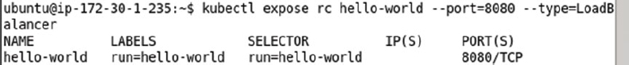

The different types of Services are ClusterIp, NodePort, and LoadBalancer with the default being ClusterIP, as discussed in [Table 2-1](https://cdn2.percipio.com/1566228253.b35c854e5d30b7b50107168ae58de19049ee01b1/eod/books/113388/OEBPS/section-18.xhtml#ch2_tab1).

| **Table 2-1: Types of Services** | |
| --- | --- |
| **Service Type** | **Description** |
| ClusterIp | Uses a cluster-internal IP only. |
| NodePort | In addition to a cluster IP exposes the Service on each node of the cluster. |
| LoadBalancer | In addition to exposing the Service on a cluster internal Ip and a port on each node on the cluster, requests the cloud provider to provide a load balancer for the Service. The load balancer balances the load between the Pods in the Service. |

List all the Kubernetes Services with the following command.

kubectl get services

In addition to the "kubernetes" Service for the Kubernetes cluster manager a "hello-world" Service gets created as shown in [Figure 2-7](https://cdn2.percipio.com/1566228253.b35c854e5d30b7b50107168ae58de19049ee01b1/eod/books/113388/OEBPS/section-18.xhtml#ch2_fig7).

Figure 2-7: Listing the Services

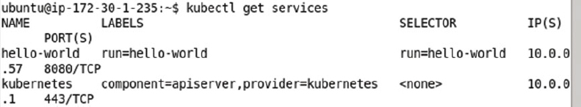

### Describing a Pod

Using the Pod name hello-world-syrqz obtained from the NAME column in the result for the kubectl get pods command use the kubectl describe pod command to list detailed information about the Pod.

kubectl describe pod hello-world-syrqz

Detailed information about the Pod including the IP address gets listed as shown in [Figure 2-8](https://cdn2.percipio.com/1566228253.b35c854e5d30b7b50107168ae58de19049ee01b1/eod/books/113388/OEBPS/section-18.xhtml#ch2_fig8). The Pod has a Label run=hello-world, which is the same as the replication controller selector and also same as the service selector, which implies that the replication controller manages the Pod when scaling the cluster of Pods for example, and the service represents the Pod to external clients.

Figure 2-8: Describing a Pod

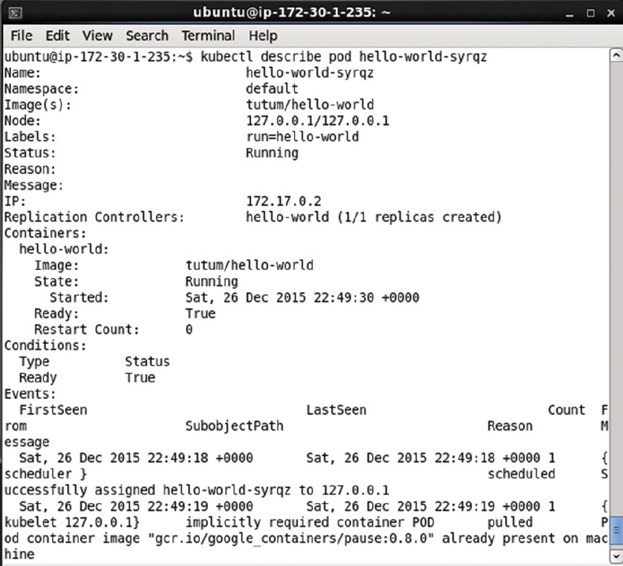

Next, we shall invoke the application using the IP Address 172.0.17.2 listed in the IP field.

### Invoking the Hello-World Application

The hello-world application may be invoked using the IP for the application as listed in [Figure 2-8](https://cdn2.percipio.com/1566228253.b35c854e5d30b7b50107168ae58de19049ee01b1/eod/books/113388/OEBPS/section-18.xhtml#ch2_fig8) with the following curl command.

curl 172.17.0.2

The HTML output from the application is shown in [Figure 2-9](https://cdn2.percipio.com/1566228253.b35c854e5d30b7b50107168ae58de19049ee01b1/eod/books/113388/OEBPS/section-18.xhtml#ch2_fig9).

Figure 2-9: Invoking a Application using Pod IP with curl

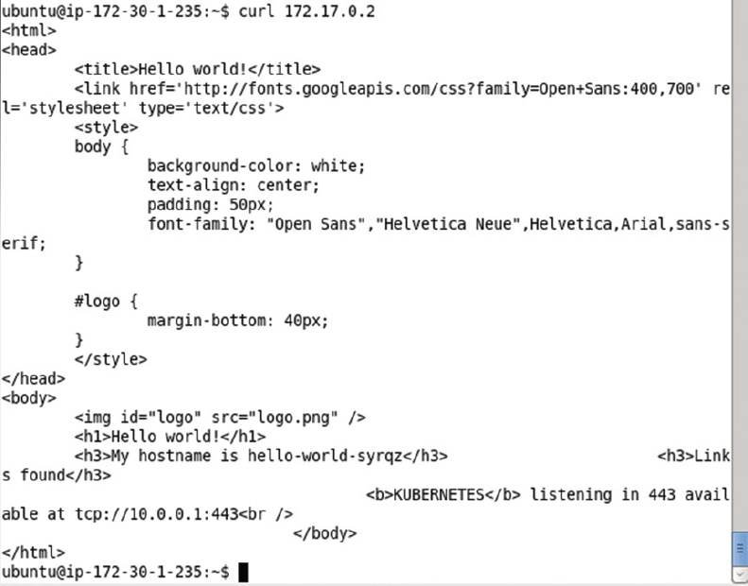

To display the HTML output in a browser we need to invoke the application from a browser using URL 172.17.0.2:80. If a browser is not available on the Amazon EC2 Ubuntu instance, as it is not by default, we need to set up a SSH tunnel to the IP Address of the application using local port forwarding. Obtain the Public DNS for the Amazon EC2 instance ([ec2-52-91-200-41.compute-1.amazonaws.com](http://ec2-52-91-200-41.compute-1.amazonaws.com/) in the example) and run the following command to set up a SSH tunnel to the 172.17.0.2:80 host:port from a local machine. The –L indicates that local port forwarding is used to forward local port 80 to 172.17.0.2:80.

ssh -i "docker.pem" -f -nNT -L 80:172.17.0.2:80 ubuntu@ec2-52-91-200-41.compute-1.amazonaws.com

Invoke the URL [http://localhost](http://localhost/) in a browser on the local machine. The HTML output from the hello-world application gets displayed as shown in [Figure 2-10](https://cdn2.percipio.com/1566228253.b35c854e5d30b7b50107168ae58de19049ee01b1/eod/books/113388/OEBPS/section-18.xhtml#ch2_fig10). The hostname is listed the same as the Pod name in [Figure 2-5](https://cdn2.percipio.com/1566228253.b35c854e5d30b7b50107168ae58de19049ee01b1/eod/books/113388/OEBPS/section-18.xhtml#ch2_fig5).

Figure 2-10: Invoking the Hello-World Application in a Browser

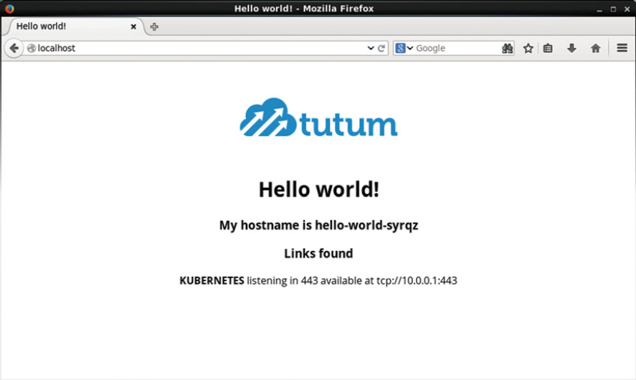

### Scaling the Application

A Replication Controller was created by default when we created the hello-world application with replicas set as 1. Next, we shall scale up the number of Pods to 4. The kubectl scale command is used to scale a Replication Controller. Run the following command to scale up the Replication Controller hello-world to 4.

kubectl scale rc hello-world --replicas=4

Subsequently, list the Pods using the following command.

kubectl get pods

The additional Pods get listed but some of the new Pods could be listed in various states such as running but not ready, or image ready and container creating as shown in [Figure 2-11](https://cdn2.percipio.com/1566228253.b35c854e5d30b7b50107168ae58de19049ee01b1/eod/books/113388/OEBPS/section-18.xhtml#ch2_fig11).

Figure 2-11: Scaling the Cluster of Pods with the Replication Controller

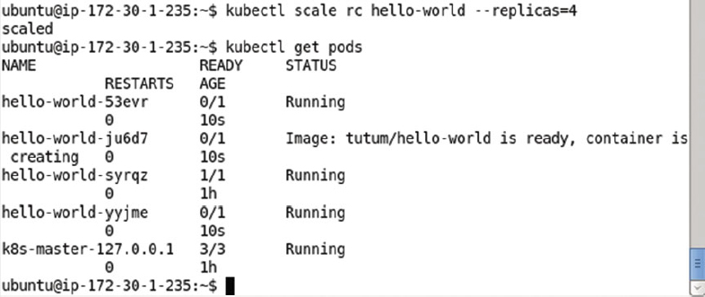

After a few seconds run the same command again to list the Pods.

kubectl get pods

If the Pods have started all the Pods are listed with STATUS- > Running and READY state 1/1 as shown in [Figure 2-12](https://cdn2.percipio.com/1566228253.b35c854e5d30b7b50107168ae58de19049ee01b1/eod/books/113388/OEBPS/section-18.xhtml#ch2_fig12). Scaling to 4 replicas does not create 4 new Pods, but the total number of Pods is scaled to 4 and the single Pod created initially is included in the new scaled replicas of 4.

Figure 2-12: Listing all the Pods as Running and Ready

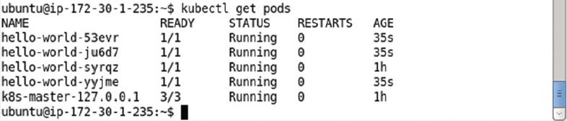

Describe the hello-world Service using the following command.

kubectl describe svc hello-world

The Service name, label/s, selector, type, IP, and Endpoints get listed as shown in [Figure 2-13](https://cdn2.percipio.com/1566228253.b35c854e5d30b7b50107168ae58de19049ee01b1/eod/books/113388/OEBPS/section-18.xhtml#ch2_fig13). The Service may be invoked using the Endpoints for the various Pod replicas.

Figure 2-13: Describing the Service hello-world

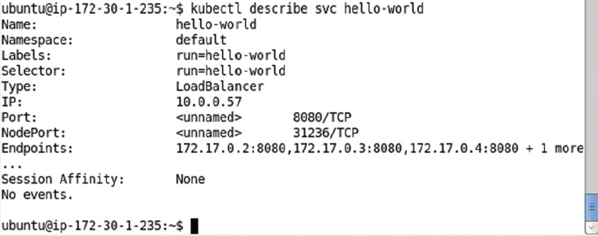

As discussed previously, set up SSH tunneling with port forwarding for the newly added endpoints. The following command sets up a SSH tunnel with port forwarding from localhost port 8081 to 172.17.0.3:80 on the Amazon EC2 instance.

ssh -i "docker.pem" -f -nNT -L 8081:172.17.0.3:80 ubuntu@ec2-52-91-200-41.compute-1.

amazonaws.com

Subsequently invoke the hello-world application in a browser on a local machine with url [http://localhost:8081](http://localhost:8081/) to display the application output as shown in [Figure 2-14](https://cdn2.percipio.com/1566228253.b35c854e5d30b7b50107168ae58de19049ee01b1/eod/books/113388/OEBPS/section-18.xhtml#ch2_fig14).

Figure 2-14: Invoking an Application in a Local Browser

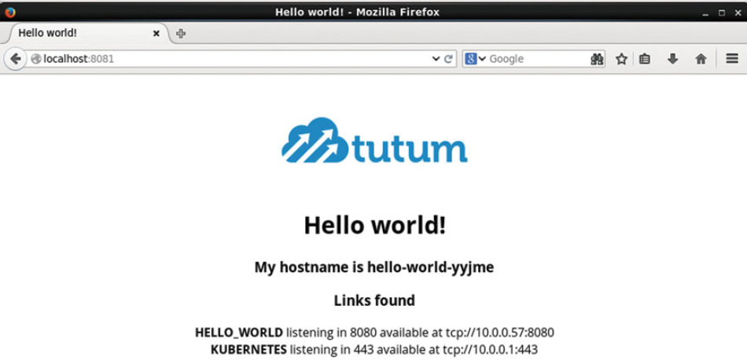

Similarly the following command from a local machine sets up a SSH tunnel with port forwarding from localhost port 8082 to 172.17.0.4:80 on the Amazon EC2 instance.

ssh -i "docker.pem" -f -nNT -L 8082:172.17.0.4:80 ubuntu@ec2-52-91-200-41.compute-1.

amazonaws.com

Subsequently invoke the hello-world application using url [http://localhost:8082](http://localhost:8082/) to display the application output as shown in [Figure 2-15](https://cdn2.percipio.com/1566228253.b35c854e5d30b7b50107168ae58de19049ee01b1/eod/books/113388/OEBPS/section-18.xhtml#ch2_fig15).

Figure 2-15: Invoking the second Service Endpoint in a Local Browser

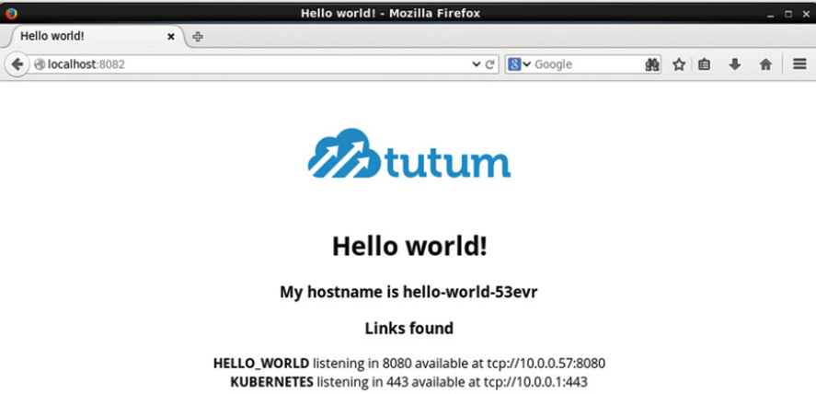

### Deleting a Replication Controller

The Replication Controller hello-world may be deleted with the following command.

kubectl delete rc hello-world

The Replication Controller gets deleted as shown in [Figure 2-16](https://cdn2.percipio.com/1566228253.b35c854e5d30b7b50107168ae58de19049ee01b1/eod/books/113388/OEBPS/section-18.xhtml#ch2_fig16). Subsequently invoke the following command to list the Replication Controllers.

Figure 2-16: Deleting a Replication Controller

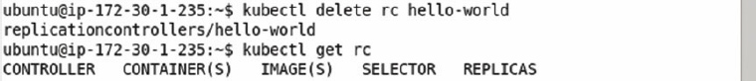

kubectl get rc

The hello-world Replication Controller does not get listed as shown in [Figure 2-16](https://cdn2.percipio.com/1566228253.b35c854e5d30b7b50107168ae58de19049ee01b1/eod/books/113388/OEBPS/section-18.xhtml#ch2_fig16).

Deleting a Replication Controller deletes the Replication Controller and the Pods associated with the Replication Controller but does not delete the Service representing the Replication Controller. The kubectl get services command still lists the Service as shown in [Figure 2-17](https://cdn2.percipio.com/1566228253.b35c854e5d30b7b50107168ae58de19049ee01b1/eod/books/113388/OEBPS/section-18.xhtml#ch2_fig17).

Figure 2-17: Deleting a Replication Controller does not delete the Service

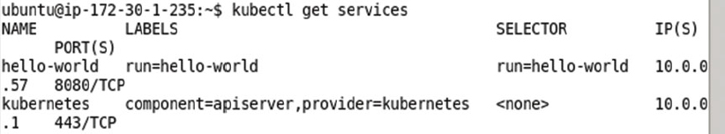

### Deleting a Service

To delete the Service hello-world run the following command.

kubectl delete svc hello-world

Subsequently invoke the following command to list the Services.

kubectl get services

The output from the preceding two commands is shown in [Figure 2-18](https://cdn2.percipio.com/1566228253.b35c854e5d30b7b50107168ae58de19049ee01b1/eod/books/113388/OEBPS/section-18.xhtml#ch2_fig18) and does not list the hello-world Service.

Figure 2-18: Deleting the hello-world Service

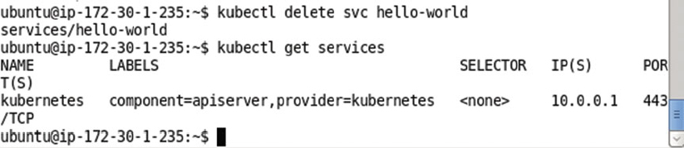

## Creating an Application Declaratively

Next, we shall create the same hello-world application declaratively using definition files for a Pod, Service, and Replication Controller. The definition files may be configured in YAML or JSON. We have used YAML initially and also discussed the JSON alternative later.

### Creating a Pod Definition

Create a hello-world.yaml file and specify a definition for a Pod in the file. For the hello-world application the following definition is used in which the apiVersion mapping is for the API schema version (v1), kind mapping is the resource and set to Pod. The metadata mapping specifies the Pod's metadata and sets the name to hello-world (arbitrary). The spec mapping specifies the Pod behavior. The spec- > containers mapping specifies a collection of images to run. The hello-world.yaml specifies a single container for image tutum/hello-world. Container name is set to hello-world and container ports mapping is a list of ports with a single containerPort mapping for 8080 port.

apiVersion: v1

kind: Pod

metadata:

name: hello-world

spec:

containers:

-

image: tutum/hello-world

name: hello-world

ports:

-containerPort: 8080

The preceding is equivalent to the following command.

kubectl run hello-world --image=tutum/hello-world --port=8080

Only a few of the schema elements have been used in the hello-world.yaml. For the complete Pod schema refer <http://kubernetes.io/v1.1/docs/api-reference/v1/definitions.html#_v1_pod>.

Next, create the hello-world application using the hello-world.yaml definition file with the following kubectl create command. The –validate option validates the Pod definition file. A YAML lint validator (<http://www.yamllint.com/>) may be used to validate the YAML syntax in the hello-world.yaml. The syntax validation does not validate if the definition file conforms to the Pod schema.

kubectl create -f hello-world.yaml --validate

A Pod called hello-world gets created as shown in [Figure 2-19](https://cdn2.percipio.com/1566228253.b35c854e5d30b7b50107168ae58de19049ee01b1/eod/books/113388/OEBPS/section-19.xhtml#ch2_fig19).

Figure 2-19: Creating a Pod using a Definition File



List the Pods with the following command, which is the same regardless of how a Pod has been created.

kubectl get pods

The hello-world Pod gets listed as shown in [Figure 2-20](https://cdn2.percipio.com/1566228253.b35c854e5d30b7b50107168ae58de19049ee01b1/eod/books/113388/OEBPS/section-19.xhtml#ch2_fig20). Initially, the Pod may not be READY-> 1/1. A READY column value of "0/1" implies that 0 of 1 containers in the Pod are ready.

Figure 2-20: Listing the Pods soon after creating the Pods

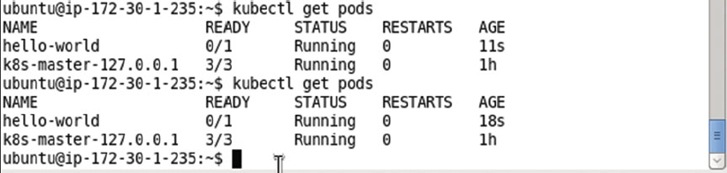

Run the same command again after a few more seconds.

kubectl get pods

The hello-world Pod gets listed with STATUS as "Running" and READY state as "1/1," which implies that 1 of 1 containers in the Pod are ready, as shown in [Figure 2-21](https://cdn2.percipio.com/1566228253.b35c854e5d30b7b50107168ae58de19049ee01b1/eod/books/113388/OEBPS/section-19.xhtml#ch2_fig21).

Figure 2-21: Listing the Pod as Ready and Running

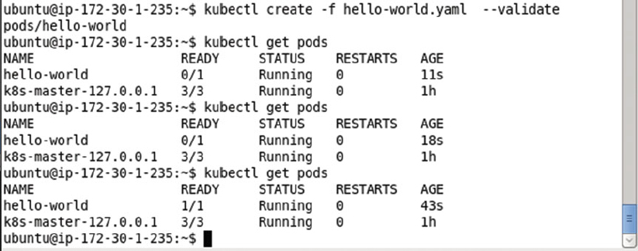

Describe the hello-world Pod with the following command.

kubectl describe pod hello-world

The output from the preceding command is shown in [Figure 2-22](https://cdn2.percipio.com/1566228253.b35c854e5d30b7b50107168ae58de19049ee01b1/eod/books/113388/OEBPS/section-19.xhtml#ch2_fig22).

Figure 2-22: Describing the hello-world Pod

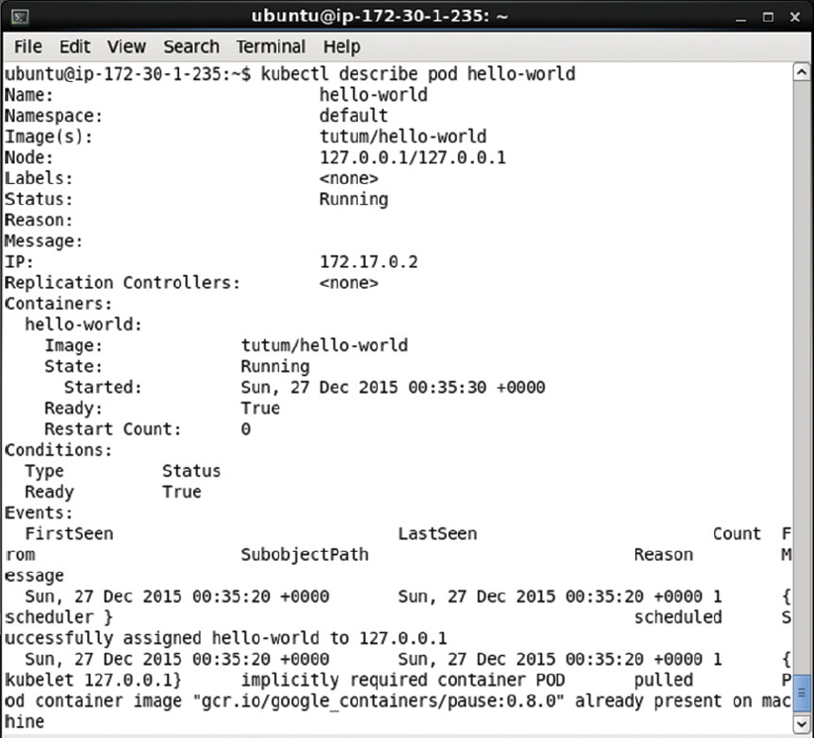

Invoke the hello-world Pod application using the IP 172.17.0.2.

curl 172.17.0.2

The HTML output from the hello-world application gets listed as shown in [Figure 2-23](https://cdn2.percipio.com/1566228253.b35c854e5d30b7b50107168ae58de19049ee01b1/eod/books/113388/OEBPS/section-19.xhtml#ch2_fig23).

Figure 2-23: Invoking the hello-world Application with curl

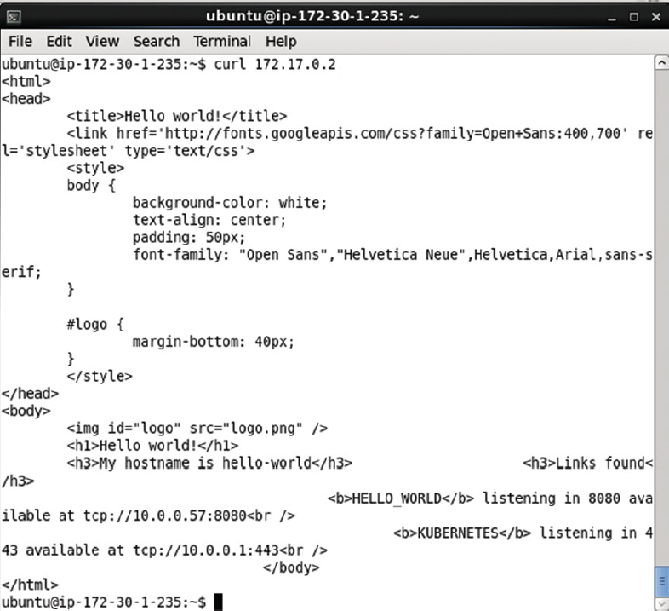

Set up port forwarding from a local machine to the IP address of the hello-world Pod.

ssh -i "docker.pem" -f -nNT -L 80:172.17.0.2:80 ubuntu@ec2-52-91-200-41.compute-1.amazonaws.com

Subsequently invoke the url [http://localhost:80](http://localhost/) in a browser on a local machine to display the HTML output from the application as shown in [Figure 2-24](https://cdn2.percipio.com/1566228253.b35c854e5d30b7b50107168ae58de19049ee01b1/eod/books/113388/OEBPS/section-19.xhtml#ch2_fig24). The default Hypertext transfer protocol port being 80, has been be omitted from the URL, as shown in [Figure 2-24](https://cdn2.percipio.com/1566228253.b35c854e5d30b7b50107168ae58de19049ee01b1/eod/books/113388/OEBPS/section-19.xhtml#ch2_fig24).

Figure 2-24: Invoking the hello-world Application in a Browser on a local machine

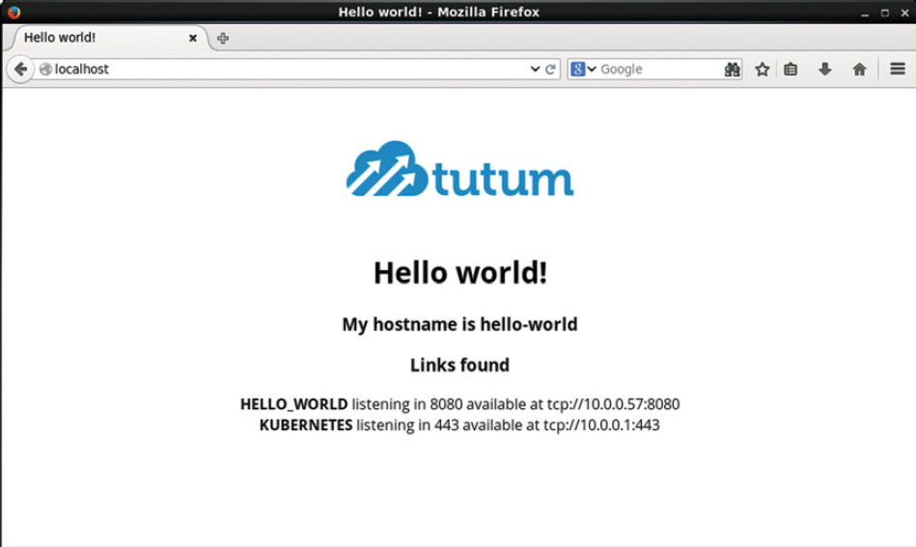

### Creating a Service Definition

We created a Pod definition file and started a single Pod, but the Pod is not associated with any Service or Replication Controller. External clients have to access the Pod directly and are not able to scale the application with just a single unassociated Pod. Create a Service definition file hello-world-service.yaml as listed below. If copying and pasting YAML files listed in this chapter and other chapters it is recommended to use the YAML Lint (<http://www.yamllint.com/>) to format the files before using in an application.

apiVersion: v1

kind: Service

metadata:

labels:

app: hello-world

name: hello-world

spec:

ports:

-

name: http

port: 80

targetPort: http

selector:

app: hello-world

type: LoadBalancer

The main mappings of the Service definition file are kind, metadata, and spec. The kind is set to Service to indicate a Kubernetes Service. The label app and the name constitute the metadata. The spec mapping includes a ports mapping for port 80 with name http. Optionally a targetPort may be set, which defaults to the same value as port. The selector is the main mapping in the spec and specifies a mapping to be used for selecting the Pods to expose via the Service. The app:hello-world selector implies that all Pods with label app=hello-world are selected. The definition file may be created in the vi editor and saved with the :wq command as shown in [Figure 2-25](https://cdn2.percipio.com/1566228253.b35c854e5d30b7b50107168ae58de19049ee01b1/eod/books/113388/OEBPS/section-19.xhtml#ch2_fig25).

Figure 2-25: Service Definition File hello-world-service.yaml

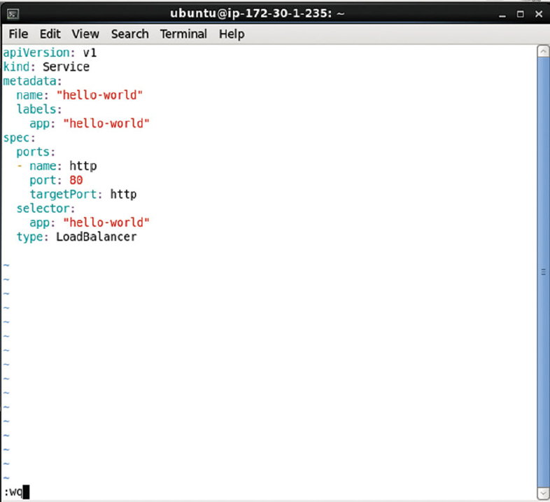

A complete reference to the Kubernetes Service schema is available at <http://kubernetes.io/v1.1/docs/api-reference/v1/definitions.html#_v1_service>.

Create a Service using the definition file with the kubectl create command.

kubectl create -f hello-world-service.yaml

The hello-world Service gets created as shown in [Figure 2-26](https://cdn2.percipio.com/1566228253.b35c854e5d30b7b50107168ae58de19049ee01b1/eod/books/113388/OEBPS/section-19.xhtml#ch2_fig26).

Figure 2-26: Creating the hello-world Service using the Definition File



List the Services with the following command.

kubectl get services

The hello-world Service gets listed in addition to the kubernetes Service as shown in [Figure 2-27](https://cdn2.percipio.com/1566228253.b35c854e5d30b7b50107168ae58de19049ee01b1/eod/books/113388/OEBPS/section-19.xhtml#ch2_fig27).

Figure 2-27: Listing the hello-world Service

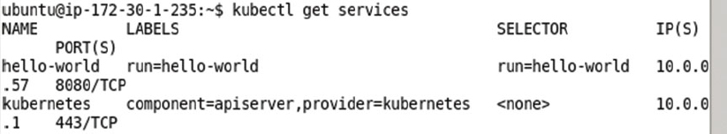

Describe the hello-world Service with the following command.

kubectl describe svc hello-world

The Service name, namespace, labels, selector, type, Ip get listed as shown in [Figure 2-28](https://cdn2.percipio.com/1566228253.b35c854e5d30b7b50107168ae58de19049ee01b1/eod/books/113388/OEBPS/section-19.xhtml#ch2_fig28). Because the hello-world Pod created using the Pod definition file does not include a label to match the Service selector, it is not managed by the Service. As the hello-world Service is not managing any Pods, no endpoint gets listed.

Figure 2-28: Describing the hello-world Service

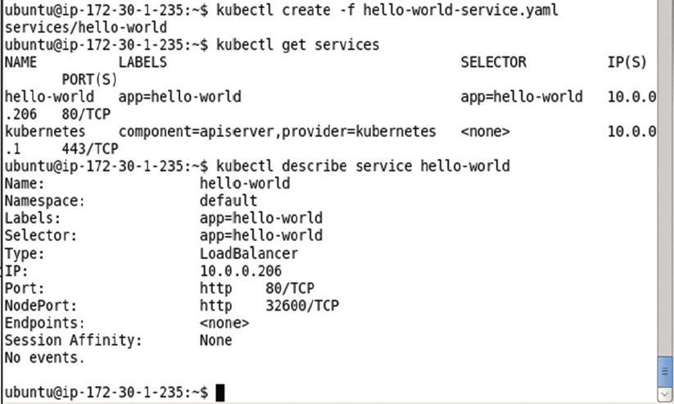

### Creating a Replication Controller Definition

Next, we shall create a Replication Controller and label the Replication Controller to match the selector of the Service created previously. Create a Service definition file hello-rc.yaml. The kind mapping of a Replication Controller is ReplicationController. The replicas' sub-mapping in the spec mapping is set to 2 to create two replicas from the Pod also specified in the spec. At least one of the labels in the template- > metadata- > labels must match the Service selector in the Service definition file for the Pod to be exposed by the Service. As the Service selector in the hello-worldService is app:hello-world add the app:hello-world label to the Replication Controller template. The app:hello-world setting in YAML translates to app=hello-world. The template may define one or more containers to be included in the Pod created from the Replication Controller. We have included container definition for only one container for image tutum/hello-world. The hello-rc.yaml is listed below. A YAML lint (<http://www.yamllint.com/>) may be used to validate the YAML syntax.

apiVersion: v1

kind: ReplicationController

metadata:

name: hello-world

spec:

replicas: 2

template:

metadata:

labels:

app: hello-world

spec:

containers:

-

image: tutum/hello-world

name: hello-world

ports:

-

containerPort: 8080

name: http

A complete schema for the Replication Controller is available at <http://kubernetes.io/v1.1/docs/api-reference/v1/definitions.html#_v1_replicationcontroller>.

Create the Replication Controller using the definition file with the kubectl create command, the same command that was used to create a Pod and a Service.

kubectl create -f hello-rc.yaml

Subsequently run the following command to list the Replication Controllers.

kubectl get rc

A hello-world Replication Controller gets created and gets listed as shown in [Figure 2-29](https://cdn2.percipio.com/1566228253.b35c854e5d30b7b50107168ae58de19049ee01b1/eod/books/113388/OEBPS/section-19.xhtml#ch2_fig29). The number of replicas are listed as 2 as specified in the definition file.

Figure 2-29: Creating a Replication Controller

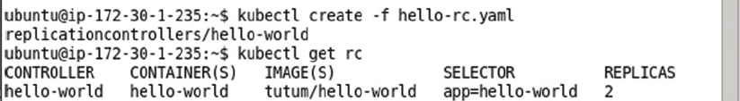

List the Pods created with the Replication Controller with the following command.

kubectl get pods

The two Pods created from the definition file get listed as shown in [Figure 2-30](https://cdn2.percipio.com/1566228253.b35c854e5d30b7b50107168ae58de19049ee01b1/eod/books/113388/OEBPS/section-19.xhtml#ch2_fig30). The Pod created the Pod definition file also gets listed but is not associated with the Replication Controller. Initially some or all of the new Pods may be listed as not ready as indicated by the 0/1 value in the READY column for one of the Pods in [Figure 2-30](https://cdn2.percipio.com/1566228253.b35c854e5d30b7b50107168ae58de19049ee01b1/eod/books/113388/OEBPS/section-19.xhtml#ch2_fig30).

Figure 2-30: Listing the Pods soon after creating a Replication Controller

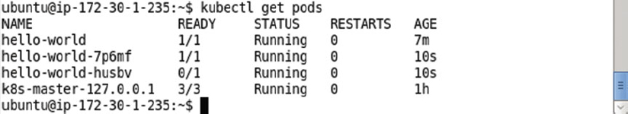

Invoke the same command again to list the Pods after a few more seconds.

kubectl get pods

All the Pods get listed as READY-> 1/1 and Running as shown in [Figure 2-31](https://cdn2.percipio.com/1566228253.b35c854e5d30b7b50107168ae58de19049ee01b1/eod/books/113388/OEBPS/section-19.xhtml#ch2_fig31).

Figure 2-31: Listing all the Pods as Running and Ready

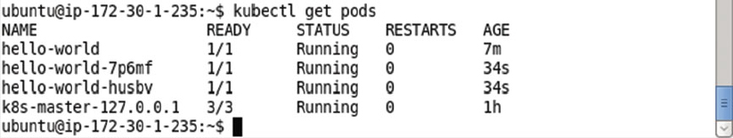

To describe the hello-world Service run the following command.

kubectl describe service hello-world

The Service detail including the Endpoints get listed as shown in [Figure 2-32](https://cdn2.percipio.com/1566228253.b35c854e5d30b7b50107168ae58de19049ee01b1/eod/books/113388/OEBPS/section-19.xhtml#ch2_fig32). The service selector is app = hello-world and the service endpoints are 172.17.0.3:8080 and 172.17.0.4:8080.

Figure 2-32: Describing the Service hello-world

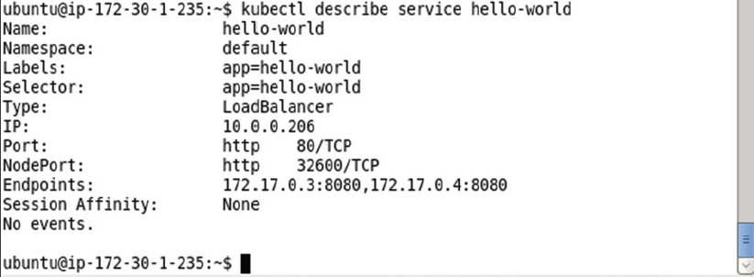

All the preceding commands to create the hello-world Replication Controller, list its Pods and endpoints association with the hello-world Service shown in [Figure 2-33](https://cdn2.percipio.com/1566228253.b35c854e5d30b7b50107168ae58de19049ee01b1/eod/books/113388/OEBPS/section-19.xhtml#ch2_fig33).

Figure 2-33: Summary of Commands to create a Replication Controller

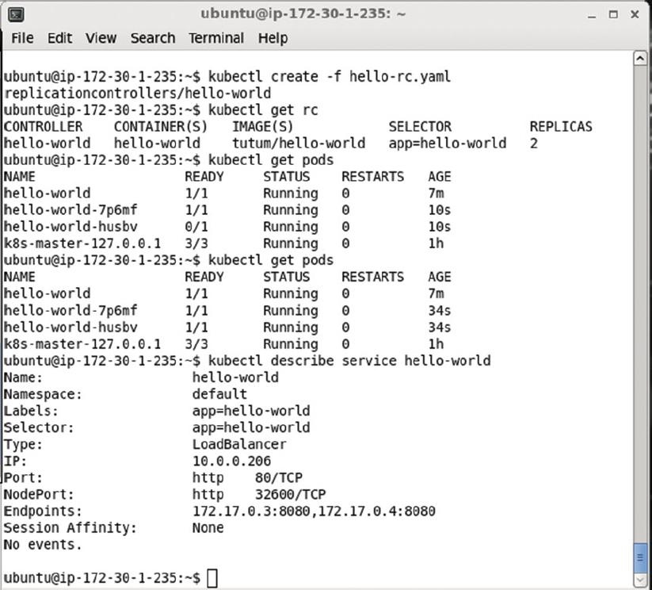

### Invoking the Hello-World Application

The Pods associated with the hello-world Replication Controller and Service by the same name may be invoked using the Service endpoints as listed in the Service description in [Figure 2-33](https://cdn2.percipio.com/1566228253.b35c854e5d30b7b50107168ae58de19049ee01b1/eod/books/113388/OEBPS/section-19.xhtml#ch2_fig33). For example, invoke the 172.17.0.3 endpoint with the following curl command.

curl 172.17.0.3

The HTML output from the Pod gets output as shown in [Figure 2-34](https://cdn2.percipio.com/1566228253.b35c854e5d30b7b50107168ae58de19049ee01b1/eod/books/113388/OEBPS/section-19.xhtml#ch2_fig34).

Figure 2-34: HTML Output from invoking the hello-world Application with curl

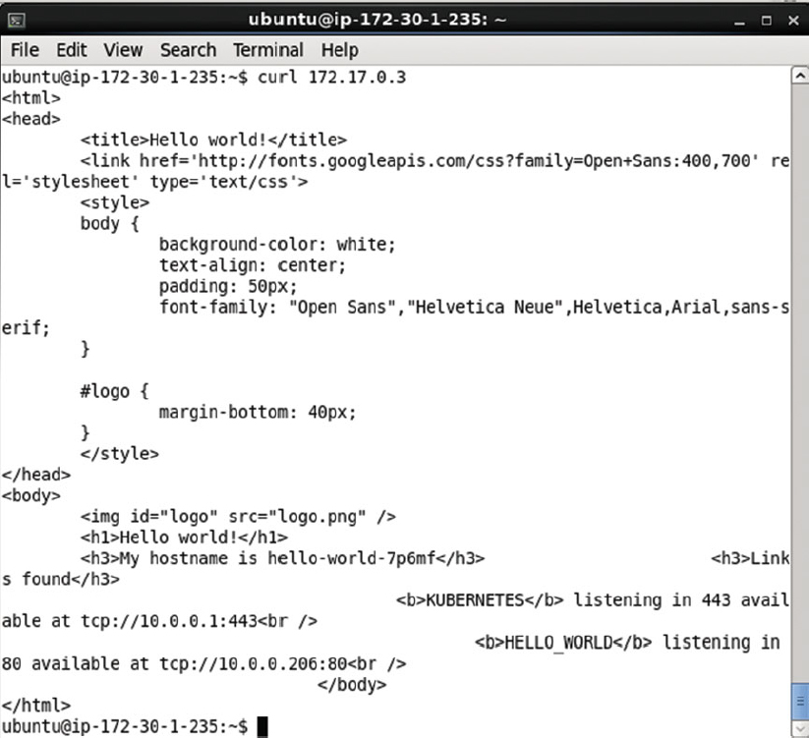

Similarly, invoke the 172.17.0.4 endpoint with the following curl command.

curl 172.17.0.4

The HTML output from the other Pod gets output as shown in [Figure 2-35](https://cdn2.percipio.com/1566228253.b35c854e5d30b7b50107168ae58de19049ee01b1/eod/books/113388/OEBPS/section-19.xhtml#ch2_fig35).

Figure 2-35: Invoking another Service Endpoint with curl

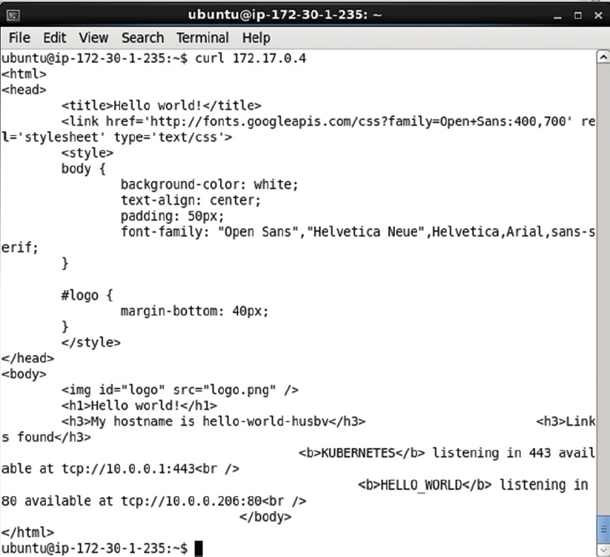

To invoke the Service endpoints in a browser on a local machine configure local port forwarding for the Service endpoints.

ssh -i "docker.pem" -f -nNT -L 8081:172.17.0.3:8080 ubuntu@ec2-52-91-200-41.compute-1.

amazonaws.com

ssh -i "docker.pem" -f -nNT -L 8082:172.17.0.4:8080 ubuntu@ec2-52-91-200-41.compute-1.

amazonaws.com

Subsequently invoke the localhost:8081 URL in a browser on a local machine as shown in [Figure 2-36](https://cdn2.percipio.com/1566228253.b35c854e5d30b7b50107168ae58de19049ee01b1/eod/books/113388/OEBPS/section-19.xhtml#ch2_fig36) to display the HTML output from the Pod at endpoint 172.17.0.3:8080.

Figure 2-36: Invoking the hello-world Application in a Local machine Browser with its Service Endpoint

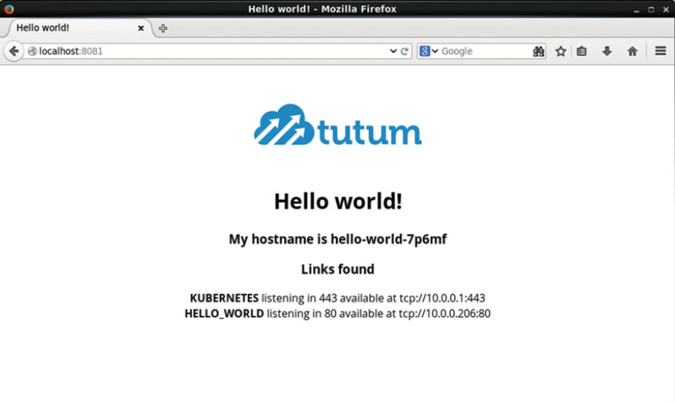

Similarly invoke the localhost:8082 URL in a browser on a local machine as shown in [Figure 2-37](https://cdn2.percipio.com/1566228253.b35c854e5d30b7b50107168ae58de19049ee01b1/eod/books/113388/OEBPS/section-19.xhtml#ch2_fig37) to display the HTML output from the Pod at endpoint 172.17.0.4:8080.

Figure 2-37: Invoking another Service Endpoint in a Browser

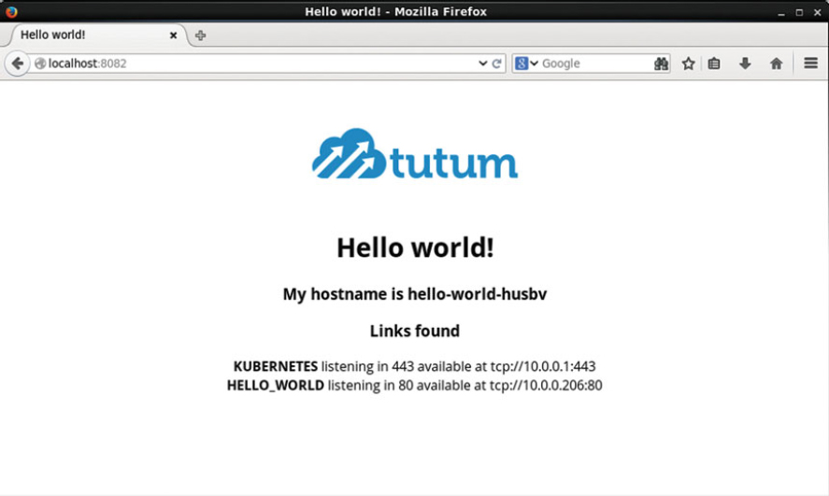

### Scaling the Application

To scale the hello-world Replication Controller to 6 replicas, for example, run the following kubectl scale command.

kubectl scale rc hello-world --replicas=6

An output of "scaled" as shown in [Figure 2-38](https://cdn2.percipio.com/1566228253.b35c854e5d30b7b50107168ae58de19049ee01b1/eod/books/113388/OEBPS/section-19.xhtml#ch2_fig38) indicates the Replication Controller has been scaled.

Figure 2-38: Scaling an Application



The number of Pods for the hello-world Replication Controller increases when the Replication Controller is scaled up to 6. To list the Pods run the following command.

kubectl get pods

Six Pods get listed in addition to the hello-world Pod created initially using a Pod definition file as shown in [Figure 2-39](https://cdn2.percipio.com/1566228253.b35c854e5d30b7b50107168ae58de19049ee01b1/eod/books/113388/OEBPS/section-19.xhtml#ch2_fig39). The preceding command may have to be run more than once to list all the Pods with STATUS as Running and READY state as 1/1. The hello-world Pod is not associated with the hello-world Replication Controller as it does not include a label that matches the selector label (same as template label) in the Replication Controller.

Figure 2-39: Listing Pods after Scaling

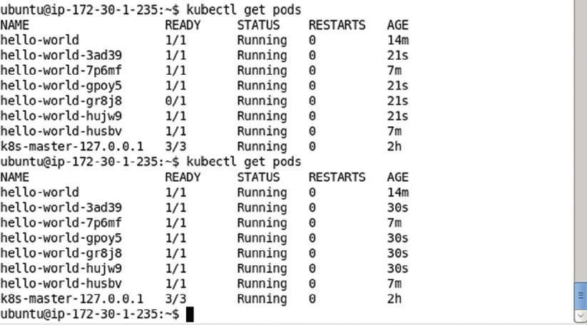

In the preceding example we scaled up the Replication Controller, but the kubectl scale command may also be used to scale down the Replication Controller. As an example, scale down the hello-world Replication Controller to 2 replicas.

kubectl scale rc hello-world --replicas=2

Subsequently list the Pods.

kubectl get pods

The number of replicas gets listed as 2 in addition to the hello-world Pod as shown in [Figure 2-40](https://cdn2.percipio.com/1566228253.b35c854e5d30b7b50107168ae58de19049ee01b1/eod/books/113388/OEBPS/section-19.xhtml#ch2_fig40).

Figure 2-40: Scaling Down to 2 Replicas

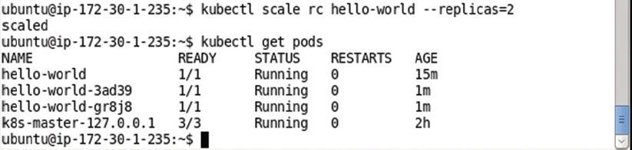

## Using JSON for the Resource Definitions

In the preceding section we used the YAML format to create the Pod, Service, and Replication Controller definition files. The definition files may be developed in JSON format instead. The YAMLToJSON utility (<http://yamltojson.com/>) may be used to convert from YAML to JSON and the JSON lint (<http://jsonlint.com/>) may be used to validate the JSON. A JSON to YAML utility is also available at <http://jsontoyaml.com/>. The JSON definition file hello-world-service.json for the hello-world Service is listed:

{

"apiVersion": "v1",

"kind": "Service",

"metadata": {

"name": "hello-world",

"labels": {

"app": "hello-world"

}

},

"spec": {

"ports": [

{

"name": "http",

"port": 80,

"targetPort": "http"

}

],

"selector": {

"app": "hello-world"

},

"type": "LoadBalancer"

}

}

Create a hello-world-service.json file using a vi editor and copy and paste the preceding listing to the file. Save the file using :wq as shown in [Figure 2-41](https://cdn2.percipio.com/1566228253.b35c854e5d30b7b50107168ae58de19049ee01b1/eod/books/113388/OEBPS/section-20.xhtml#ch2_fig41).

Figure 2-41: Service Definition File in JSON Format

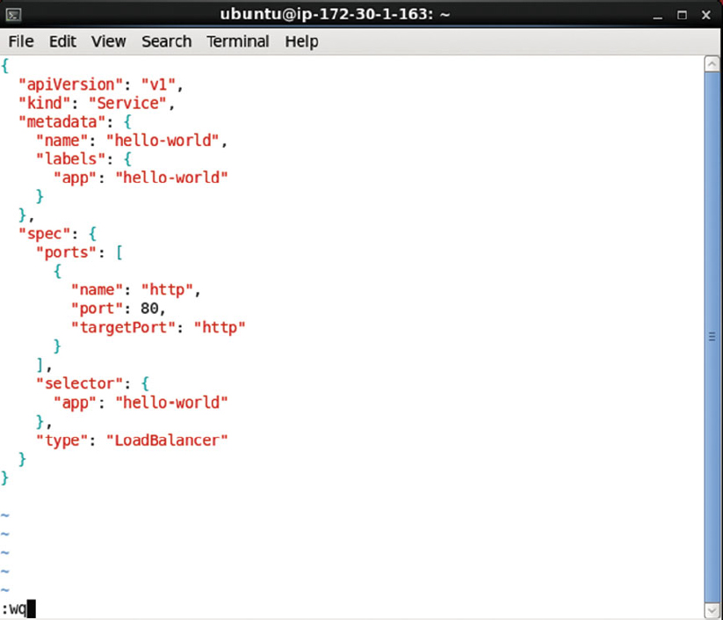

Delete the hello-world Service and hello-world Replication Controller created previously. Run the following command to create a Service from the JSON format definition file.

kubectl create –f hello-world-service.json

The hello-world Service gets created as shown in [Figure 2-42](https://cdn2.percipio.com/1566228253.b35c854e5d30b7b50107168ae58de19049ee01b1/eod/books/113388/OEBPS/section-20.xhtml#ch2_fig42).

Figure 2-42: Creating a Service from the JSON Definition File



Subsequently list all the Kubernetes Services.

kubectl get services

The hello-world Service gets listed as shown in [Figure 2-43](https://cdn2.percipio.com/1566228253.b35c854e5d30b7b50107168ae58de19049ee01b1/eod/books/113388/OEBPS/section-20.xhtml#ch2_fig43).

Figure 2-43: Listing the Services

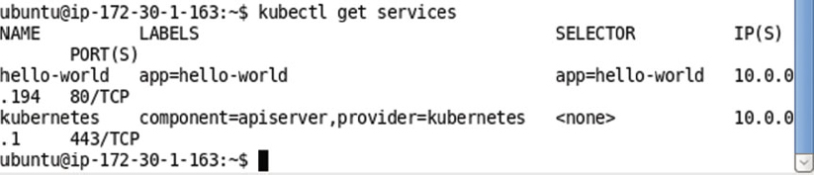

The JSON format version of the Replication Controller definition file, hello-rc.json, is as follows.

{

"apiVersion": "v1",

"kind": "ReplicationController",

"metadata": {

"name": "hello-world"

},

"spec": {

"replicas": 2,

"template": {

"metadata": {

"labels": {

"app": "hello-world"

}

},

"spec": {

"containers": [

{

"image": "tutum/hello-world",

"name": "hello-world",

"ports": [

{

"containerPort": 8080,

"name": "http"

}

]

}

]

}

}

}

}

Create the hello-rc.json file inavieditor and save the filewith :wq as shown in [Figure 2-44](https://cdn2.percipio.com/1566228253.b35c854e5d30b7b50107168ae58de19049ee01b1/eod/books/113388/OEBPS/section-20.xhtml#ch2_fig44).

Figure 2-44: Creating the hello-rc.json File in vi Editor

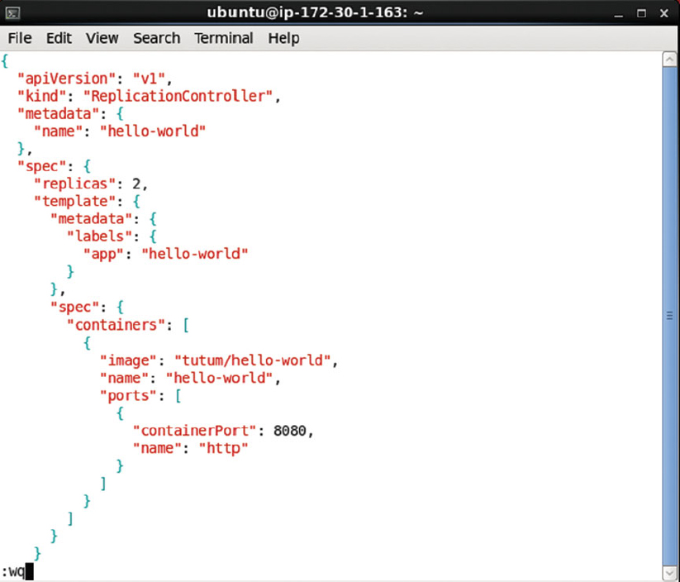

Delete all previously created Pods and Replication Controllers. Run the following command to create the hello-world Replication Controller.

kubectl create –f hello-rc.json

The hello-world Replication Controller gets created as shown in [Figure 2-45](https://cdn2.percipio.com/1566228253.b35c854e5d30b7b50107168ae58de19049ee01b1/eod/books/113388/OEBPS/section-20.xhtml#ch2_fig45). Subsequently run the following command to list the Replication Controllers.

kubectl get rc

The hello-world Replication Controller gets listed as shown in [Figure 2-45](https://cdn2.percipio.com/1566228253.b35c854e5d30b7b50107168ae58de19049ee01b1/eod/books/113388/OEBPS/section-20.xhtml#ch2_fig45). List the Pods created by the Replication Controller using the following command.

kubectl get pods

Because replicas is set as 2 two Pods get listed as shown in [Figure 2-45](https://cdn2.percipio.com/1566228253.b35c854e5d30b7b50107168ae58de19049ee01b1/eod/books/113388/OEBPS/section-20.xhtml#ch2_fig45).

Figure 2-45: Creating a Replication Controller from the JSON format Definition File

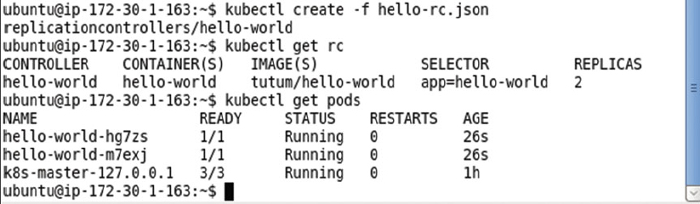

Describe the hello-world Service with the following command.

kubectl describe svc hello-world

Because the label on the hello-world Replication Controller matches the Service selector, the two Pods created using the Replication Controller are represented by the Service and have endpoints in the Service as shown in [Figure 2-46](https://cdn2.percipio.com/1566228253.b35c854e5d30b7b50107168ae58de19049ee01b1/eod/books/113388/OEBPS/section-20.xhtml#ch2_fig46).

Figure 2-46: Describing the hello-world Service

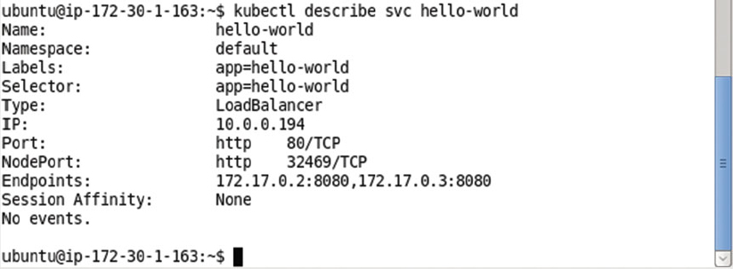

Invoke a Service endpoint using a curl command as follows.

curl 172.17.0.2

The HTML output from the curl command gets output as shown in [Figure 2-47](https://cdn2.percipio.com/1566228253.b35c854e5d30b7b50107168ae58de19049ee01b1/eod/books/113388/OEBPS/section-20.xhtml#ch2_fig47).

Figure 2-47: Invoking the hello-world Application with curl

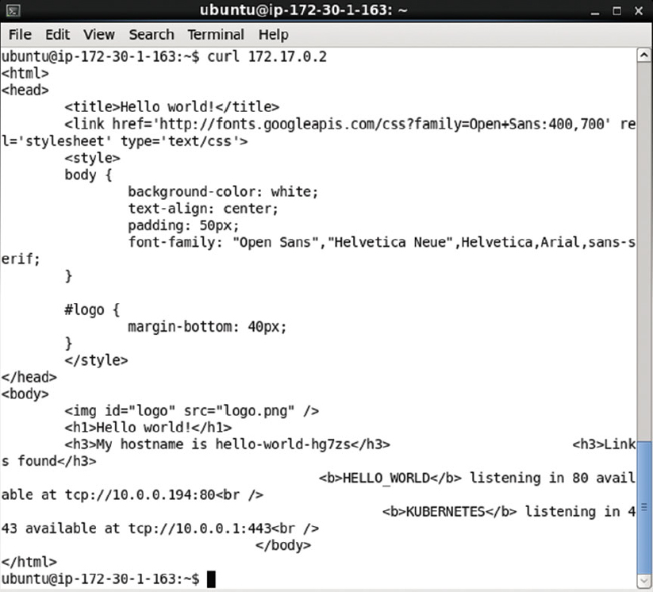

Set up local port forwarding to a Service endpoint.

ssh -i "docker.pem" -f -nNT -L 80:172.17.0.2:8080 ubuntu@ec2-52-91-200-41.compute-1.

amazonaws.com

Subsequently invoke the Service endpoint in a browser in a local machine to display the HTML output as shown in [Figure 2-48](https://cdn2.percipio.com/1566228253.b35c854e5d30b7b50107168ae58de19049ee01b1/eod/books/113388/OEBPS/section-20.xhtml#ch2_fig48).

Figure 2-48: Displaying hello-world Application HTML in a Browser

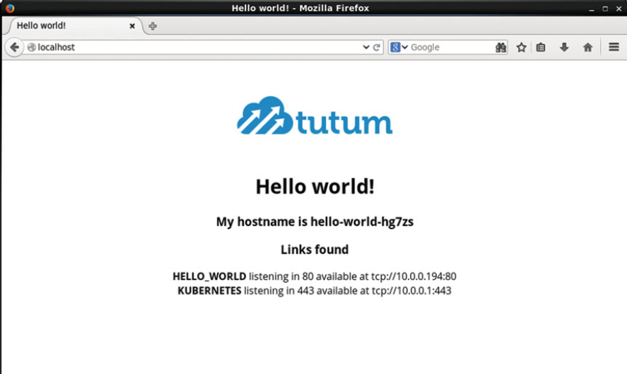

## Summary

In this chapter we introduced the Kubernetes concepts such as Pod, Service, Replication Controller, Labels, and Selector. We also developed a hello-world application both imperatively on the command line, and declaratively using definition files. We discussed two different supported formats for the definition files: YAML and JSON. In the next chapter we shall discuss using environment variables in Pod definitions.

## Chapter 3: Using Custom Commands and Environment Variables

**© Deepak Vohra 2016  
D. Vohra, Kubernetes Microservices with Docker, DOI 10.1007/978-1-4842-1907-2_3**

### Overview

Kubernetes orchestrates Docker containers, and the instructions to run for a Docker image are specified in the Dockerfile. The ENTRYPOINT instruction specifies the command to run, and the CMDinstruction specifies the default arguments for the ENTRYPOINT command. Kubernetes provides two fields, "Command" and "Args", to be specified for a container image in a Pod definition to override the default settings of ENTRYPOINT and CMD. We shall discuss these fields in this chapter. We shall also discuss using environment variables in a Pod definition's container mapping with the "env"field mapping.

**Setting the Environment**

The following software is used in this chapter.

* -Docker Engine (latest version)
* -Kubernetes (version 1.01)
* -Kubectl (version 1.01)

Install Docker engine, Kubernetes, and Kubectl as discussed in [chapter 1](https://cdn2.percipio.com/1566228253.b35c854e5d30b7b50107168ae58de19049ee01b1/eod/books/113388/OEBPS/chapter-1-3.xhtml#ch001). Start Docker Engine and verify its status with the following commands.

sudo service docker start

sudo service docker status

The output shown in [Figure 3-1](https://cdn2.percipio.com/1566228253.b35c854e5d30b7b50107168ae58de19049ee01b1/eod/books/113388/OEBPS/section-23.xhtml#ch3_fig1) indicates that Docker is running.

Figure 3-1: Starting Docker and Verifying Its Status

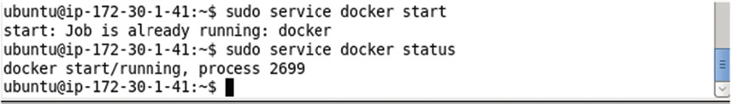

## The ENTRYPOINT and CMD Instructions

The ENTRYPOINT in a Docker image's Dockerfile specifies the command to run when the image is run. The ENTRYPOINT has two forms discussed in [Table 3-1](https://cdn2.percipio.com/1566228253.b35c854e5d30b7b50107168ae58de19049ee01b1/eod/books/113388/OEBPS/section-24.xhtml#ch3_tab1). A Dockerfile may have only one ENTRYPOINT. If multiple ENTRYPOINTs are specified, the last ENTRYPOINT entry is run.

| **Table 3-1: ENTRYPOINT Forms** | | |
| --- | --- | --- |
| **Form** | **Description** | **Format** |
| Exec form | Runs an executable using the specified parameters. The exec form is the preferred form if environment variable substitution is not used. But if environment variable substitution is used the shell form must be used. The exec form does not perform any environment variable substitution. | ENTRYPOINT ["executable"", "param1", "param2"] |
| Shell form | Runs the command in a shell and prevents any CMD or run command-line arguments to be used in conjunction with ENTRYPOINT. The shell form starts a shell with /bin/sh -c even though a shell is not invoked explicitly. | ENTRYPOINT command param1 param2 |

| **Table 3-2: CMD Forms** | | | |
| --- | --- | --- | --- |
| **Form** | **Description** | **Format** |
| Exec form | The exec form specifies the command to invoke and the command parameters in JSON array format. The exec form does not perform environment variable substitution. If environment variable substitution is to be performed, use the shell form or invoke the shell explicitly in the exec form. In JSONs array format, double quotes "" must be used around names. | CMD ["executable", "param1", "param2"] |
| Default parameters to ENTRYPOINT | Specifies the default args to the ENTRYPOINT command. Both the ENTRYPOINT and CMD must be specified. Both the ENTRYPOINT and CMD must be specified using JSON array formats. In JSONs array format, double quotes "" must be used around names. | CMD ["param1", "param2" |
| Shell form | Invokes a shell to invoke the specified command using the parameters. The command is invoked as a sub-command of /bin/sh -c. | CMD command param1 param2 |

The CMD instruction specifies the args for the ENTRYPOINT command in exec form. The CMD has three forms as discussed in [Table 3-2](https://cdn2.percipio.com/1566228253.b35c854e5d30b7b50107168ae58de19049ee01b1/eod/books/113388/OEBPS/section-24.xhtml#ch3_tab2). A Dockerfile may have only one CMD entry. If multiple CMDs are specified the last CMD entry is run. The CMD instruction may include an executable.

If command-line args are provided to the docker run command those override the default args in CMD instruction. The ENTRYPOINT instruction could also be used in combination with a helper script. Next, we shall discuss the two fields, "command" and "args" that could be used to override the ENTRYPOINT and CMD instructions in a Dockerfile respectively.

## The Command and Args Fields in a Pod Definition

Kubernetes has the provision to override the ENTRYPOINT (command) and CMD (args) instructions specified in the Dockerfile. Two field mappings in a Pod's definition file could be used to override the ENTRYPOINT and CMD instructions. These fields are "Command" and "Args," and they override the Dockerfile "ENTRYPOINT "and "CMD" instructions respectively. The overriding applies based on which of these instructions and fields are specified. Some examples of overriding are discussed in [Table 3-3](https://cdn2.percipio.com/1566228253.b35c854e5d30b7b50107168ae58de19049ee01b1/eod/books/113388/OEBPS/section-25.xhtml#ch3_tab3).

| **Table 3-3: Examples of Overriding ENTRYPOINT and CMD with Command and Args** | | | | | |
| --- | --- | --- | --- | --- | --- |
|  | **ENTRYPOINT** | **CMD** | **Command** | **Args** | **Used** |
| Example 1 | yes | yes | yes | yes | The Command and Args field mappings in the Pod definition file override the ENTRYPOINT and CMD instructions in Dockerfile. |
| Example 2 | yes | yes | no | no | The Dockerfile ENTRYPOINT command and CMD args are used. |
| Example 3 | yes | yes | yes | no | Only the command in the Command is used and Dockerfile ENTRYPOINT and CMD instructions are ignored. |
| Example 4 | yes | yes | no | yes | The Docker image's command as specified in the ENTRYPOINT is used with the args specified in the Pod definition's Args. The args from the Dockerfile's CMD are ignored. |
| Example 5 | no | yes | no | no | The command and parameters from the CMD instruction are run. |
| Example 6 | no | yes | yes | yes | The Command and Args field mappings in the Pod definition file are used. The CMD instruction in Dockerfile is overridden. |
| Example 7 | no | yes | no | yes | The Args field mapping in the Pod definition file is used. The CMD instruction in Dockerfile is overridden. |
| Example 8 | no | yes | yes | no | The command in the Command mapping is used, and Dockerfile CMD instruction is ignored. |

## Environment Variables

A Pod's schema has the provision to specify environment variables. The environment variables are specified as "name" and "value" field mappings as a collection within a container definition's "env" mapping. The format for specifying environment variables is as follows.

spec:

containers:

-

image: "image name"

name: "container name "

env:

-

name: "env variable 1"

value: " env variable 1 value"

-

name: "env variable 2"

value: " env variable 2 value"

The environment variables are added to the docker run command using -e when the Docker image is run by Kubernetes. The environment variables may also be used in "command" and "args" mappings using the environment variable substitution if a shell is used to run the Docker image command. A shell is invoked if one or more of the following is used:

* -The shell form of the ENTRYPOINT or CMD is used
* -The shell is invoked explicitly in the ENTRYPOINT or CMD instruction

In the following sections we shall use the "ubuntu" Docker image to demonstrate overriding the default ENTRYPOINT command and the default CMD args. We shall start with using the default ENTRYPOINT and CMD instructions.

## Using the Default ENTRYPOINT and CMD from a Docker Image

The Dockerfile for the Ubuntu image does not provide an ENTRYPOINT instruction but the CMD instruction is set to CMD ["/bin/bash"]. In the example in this section we shall create a Pod definition that does not override the ENTRYPOINT or CMD instruction from the Docker image. Create a Pod definition file as follows with the image as "ubuntu" and some environment variables set.

apiVersion: v1

kind: Pod

metadata:

name: "hello-world"

labels:

app: "helloApp"

spec:

restartPolicy: Never

containers:

-

image: "ubuntu"

name: "hello"

ports:

containerPort: 8020

env:

-

name: "MESSAGE1"

value: "hello"

-

name: "MESSAGE2"

value: "kubernetes"

The env.yaml file may be created in a vi editor and saved with the :wq command as shown in [Figure 3-2](https://cdn2.percipio.com/1566228253.b35c854e5d30b7b50107168ae58de19049ee01b1/eod/books/113388/OEBPS/section-27.xhtml#ch3_fig2).

Figure 3-2: A Pod definition file env.yaml to demonstrate Environment Variables

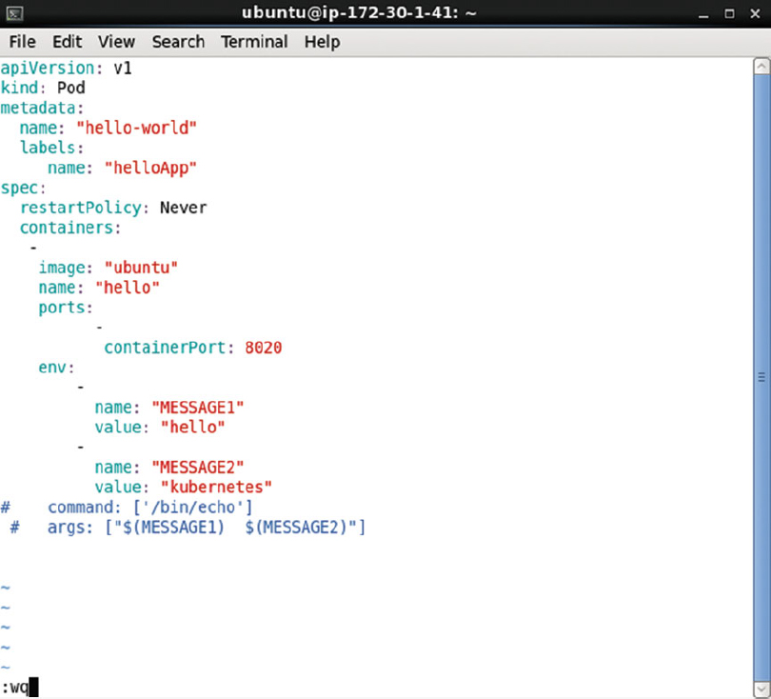

Run the following command to create a Pod from the definition file env.yaml.

kubectl create –f env.yaml

The hello-world pod gets created as shown in [Figure 3-3](https://cdn2.percipio.com/1566228253.b35c854e5d30b7b50107168ae58de19049ee01b1/eod/books/113388/OEBPS/section-27.xhtml#ch3_fig3). Run the following command to list the pods.

Figure 3-3: Creating and listing a Pod

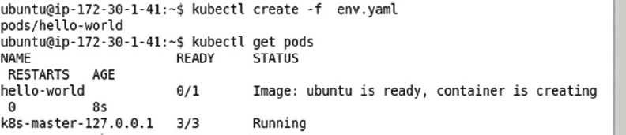

kubectl get pods

The hello-world pod gets created but the Docker container created is listed as "creating" as shown in [Figure 3-3](https://cdn2.percipio.com/1566228253.b35c854e5d30b7b50107168ae58de19049ee01b1/eod/books/113388/OEBPS/section-27.xhtml#ch3_fig3).

When the Docker container gets created the STATUS column value transitions to "Running" and the READY column value becomes 1/1, which indicates that 1 of 1 containers in the Pod are ready and which is not shown in [Figure 3-4](https://cdn2.percipio.com/1566228253.b35c854e5d30b7b50107168ae58de19049ee01b1/eod/books/113388/OEBPS/section-27.xhtml#ch3_fig4) because the READY state transitions to 0/1 quickly thereafter. After the Pod command/args have run the Pod terminates and STATUS becomes ExitCode:0 as shown in [Figure 3-4](https://cdn2.percipio.com/1566228253.b35c854e5d30b7b50107168ae58de19049ee01b1/eod/books/113388/OEBPS/section-27.xhtml#ch3_fig4).

Figure 3-4: After the Command/Args have run, a Pod terminates and the Pod's Status becomes ExitCode:0

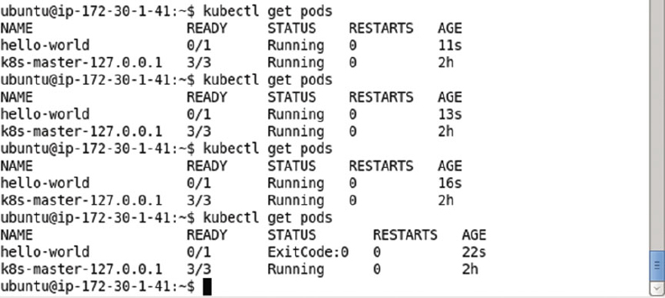

Run the following command to list the output from the Pod.

kubectl logs hello-world

As the default CMD ["/bin/bash"] in the "Ubuntu" Docker image is just the invocation of the bash shell using /bin/bash, no output is generated as shown in [Figure 3-5](https://cdn2.percipio.com/1566228253.b35c854e5d30b7b50107168ae58de19049ee01b1/eod/books/113388/OEBPS/section-27.xhtml#ch3_fig5).

Figure 3-5: No output generated with Default CMD ["/bin/bash"] in "ubuntu" Docker Image



## Overriding Both the ENTRYPOINT and CMD

In the second example we shall override both the ENTRYPOINT and CMD in a Dockerfile using Command and Args mappings in the Pod definition file. Using in combination ENTRYPOINT and CMD will help us to specify the default executable for the image and also it will provide the default arguments to that executable. Environment variable substitution is used for the MESSAGE1 and MESSAGE2environment variables with the $(VARIABLE_NAME) syntax.

command: ["/bin/echo"]

args: [" $(MESSAGE1)", " $(MESSAGE2)"]

The env.yaml Pod definition file is listed:

apiVersion: v1

kind: Pod

metadata:

name: "hello-world"

labels:

app: "helloApp"

spec:

restartPolicy: Never

containers:

-

image: "ubuntu"

name: "hello"

ports:

-

containerPort: 8020

env:

-

name: "MESSAGE1"

value: "hello"

-

name: "MESSAGE2"

value: "kubernetes"

command: ["/bin/echo"]

args: [" $(MESSAGE1)", " $(MESSAGE2)"]

The env.yaml file may be opened and modified in the vi editor and saved using the :wq command as shown in [Figure 3-6](https://cdn2.percipio.com/1566228253.b35c854e5d30b7b50107168ae58de19049ee01b1/eod/books/113388/OEBPS/section-28.xhtml#ch3_fig6).

Figure 3-6: Modifying env.yaml in a vi Editor

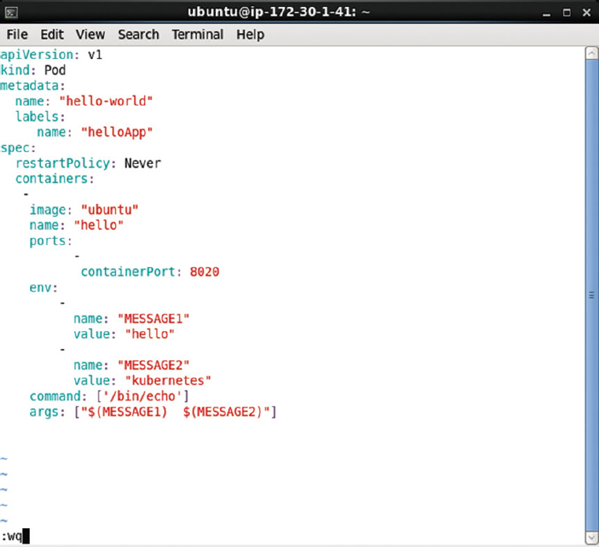

First, we need to delete the hello-world pod created in the first example with the following command.

kubectl delete pod hello-world

The hello-world pod gets deleted as shown in [Figure 3-7](https://cdn2.percipio.com/1566228253.b35c854e5d30b7b50107168ae58de19049ee01b1/eod/books/113388/OEBPS/section-28.xhtml#ch3_fig7).

Figure 3-7: Deleting the hello-world Pod



Run the kubectl create command to create a Pod from the definition file env.yaml.

kubectl create –f env.yaml

The hello-world Pod gets created as shown in [Figure 3-8](https://cdn2.percipio.com/1566228253.b35c854e5d30b7b50107168ae58de19049ee01b1/eod/books/113388/OEBPS/section-28.xhtml#ch3_fig8).

Figure 3-8: Creating the hello-world Pod from definition file env.yaml



Run the kubectl get command to list the pods.

kubectl get pods

The hello-world pod gets listed as shown in [Figure 3-9](https://cdn2.percipio.com/1566228253.b35c854e5d30b7b50107168ae58de19049ee01b1/eod/books/113388/OEBPS/section-28.xhtml#ch3_fig9). The Pod transitions quickly from the STATUS of "Running" to ExitCode:0 as shown in [Figure 3-9](https://cdn2.percipio.com/1566228253.b35c854e5d30b7b50107168ae58de19049ee01b1/eod/books/113388/OEBPS/section-28.xhtml#ch3_fig9).

Figure 3-9: Listing the Pods with transitioning STATUS value

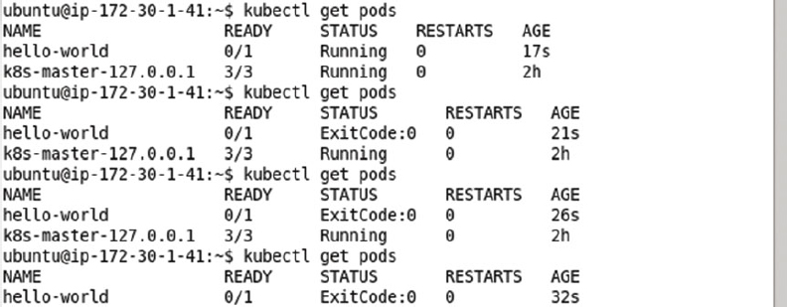

Run the following command to list the output from the Pod.

kubectl logs hello-world

The message created from environment variables MESSAGE1 and MESSAGE2 using substitution gets listed as shown in [Figure 3-10](https://cdn2.percipio.com/1566228253.b35c854e5d30b7b50107168ae58de19049ee01b1/eod/books/113388/OEBPS/section-28.xhtml#ch3_fig10).

Figure 3-10: Outputting Message Generated from Environment Variables using Value Substitution



## Specifying both the Executable and the Parameters in the Command Mapping

In the third example, specify that both the executable and the parameters are specified in the Command mapping in the Pod definition file. Environment variable substitution is used for the MESSAGE1 and MESSAGE2 environment variables. The shell is not required to be invoked/started explicitly if the environment variable syntax $(VARIABLE_NAME) is used, which is what we have used.

command: ["/bin/echo", " $(MESSAGE1)", " $(MESSAGE2)"]

The env.yaml Pod definition file is listed:

apiVersion: v1

kind: Pod

metadata:

name: "hello-world"

labels:

app: "helloApp"

spec:

restartPolicy: Never

containers:

-

image: "ubuntu"

name: "hello"

ports:

-

containerPort: 8020

env:

-

name: "MESSAGE1"

value: "hello"

-

name: "MESSAGE2"

value: "kubernetes"

command: ["/bin/echo", " $(MESSAGE1)", " $(MESSAGE2)"]

The env.yaml file may be opened and modified in the vi editor and saved using the :wq command as shown in [Figure 3-11](https://cdn2.percipio.com/1566228253.b35c854e5d30b7b50107168ae58de19049ee01b1/eod/books/113388/OEBPS/section-29.xhtml#ch3_fig11).

Figure 3-11: The Command mapping with both the Command Executable and the Parameters

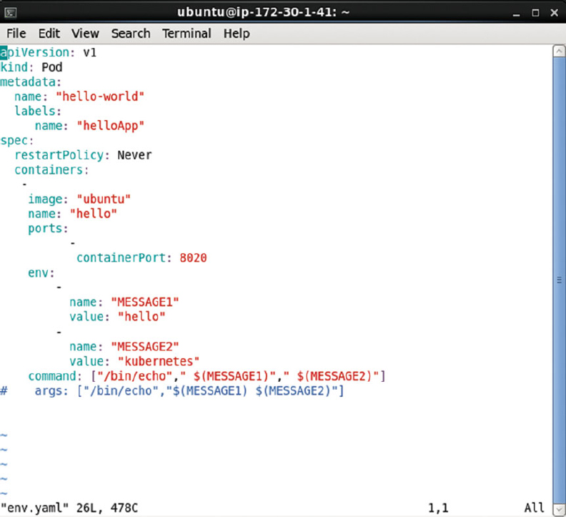

Run the kubectl create command to create a Pod from the definition file env.yaml.

kubectl create –f env.yaml

The hello-world pod gets created as shown in [Figure 3-12](https://cdn2.percipio.com/1566228253.b35c854e5d30b7b50107168ae58de19049ee01b1/eod/books/113388/OEBPS/section-29.xhtml#ch3_fig12). Run the kubectl get command to list the pods.

Figure 3-12: Creating and Listing the Pod with Definition file from [Figure 3-11](https://cdn2.percipio.com/1566228253.b35c854e5d30b7b50107168ae58de19049ee01b1/eod/books/113388/OEBPS/section-29.xhtml#ch3_fig11)

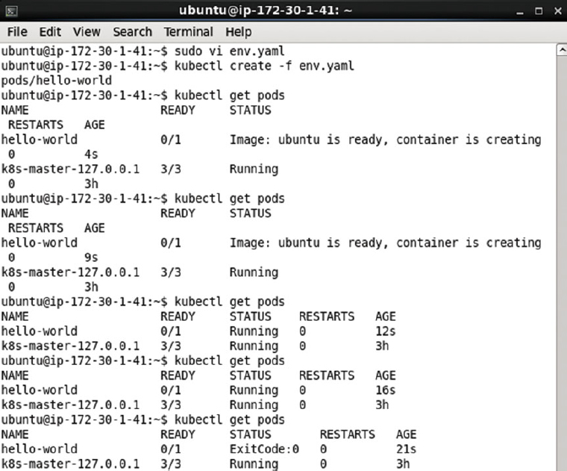

kubectl get pods

The hello-world pod gets listed though initially the Pod STATUS is not listed as "Running" as shown in [Figure 3-12](https://cdn2.percipio.com/1566228253.b35c854e5d30b7b50107168ae58de19049ee01b1/eod/books/113388/OEBPS/section-29.xhtml#ch3_fig12). The Pod transitions quickly to the READY value of 1/1 and subsequently 0/1. The 1/1 READY value is not shown in [Figure 3-12](https://cdn2.percipio.com/1566228253.b35c854e5d30b7b50107168ae58de19049ee01b1/eod/books/113388/OEBPS/section-29.xhtml#ch3_fig12) as it transitions quickly to 0/1. After the command has run the Pod terminates and the STATUS becomes ExitCode:0 as shown in [Figure 3-12](https://cdn2.percipio.com/1566228253.b35c854e5d30b7b50107168ae58de19049ee01b1/eod/books/113388/OEBPS/section-29.xhtml#ch3_fig12).

Subsequently invoke the following command to list the output generated by the Pod.

kubectl get logs

The message created from environment variables MESSAGE1 and MESSAGE2 gets listed as shown in [Figure 3-13](https://cdn2.percipio.com/1566228253.b35c854e5d30b7b50107168ae58de19049ee01b1/eod/books/113388/OEBPS/section-29.xhtml#ch3_fig13).

Figure 3-13: Message output by Pod created in [Figure 3-12](https://cdn2.percipio.com/1566228253.b35c854e5d30b7b50107168ae58de19049ee01b1/eod/books/113388/OEBPS/section-29.xhtml#ch3_fig12)



## Specifying Both the Executable and the Parameters in the Args Mapping

In the fourth example, specify both the executable and the parameters in the Args mapping in the Pod definition file as a result overriding the CMD instruction in the Dockerfile. Environment variable substitution is used for the MESSAGE1 and MESSAGE2 environment variables with the environment variable syntax $(VARIABLE_NAME).

args: ["/bin/echo", " $(MESSAGE1)", " $(MESSAGE2)"]

The env.yaml Pod definition file is listed:

apiVersion: v1

kind: Pod

metadata:

name: "hello-world"

labels:

app: "helloApp"

spec:

restartPolicy: Never

containers:

-

image: "ubuntu"

name: "hello"

ports:

-

containerPort: 8020

env:

-

name: "MESSAGE1"

value: "hello"

-

name: "MESSAGE2"

value: "kubernetes"

args: ["/bin/echo", " $(MESSAGE1)", " $(MESSAGE2)"]

The env.yaml file may be opened and modified in the vi editor and saved using the :wq command as shown in [Figure 3-14](https://cdn2.percipio.com/1566228253.b35c854e5d30b7b50107168ae58de19049ee01b1/eod/books/113388/OEBPS/section-30.xhtml#ch3_fig14).

Figure 3-14: The args Mapping in the Pod definition file specifies both the Command Executable and the Parameters

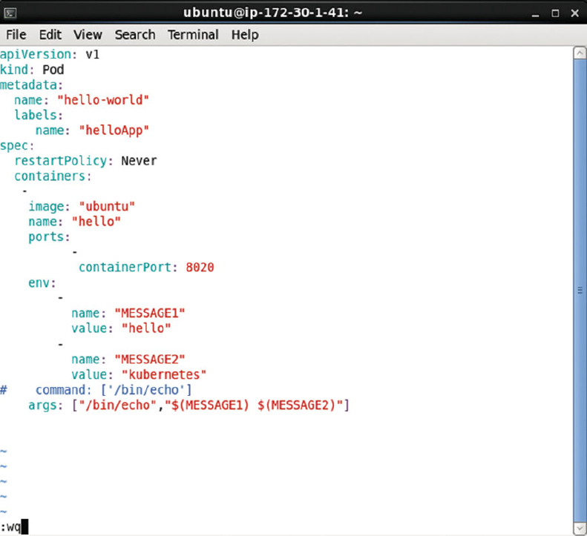

The hello-world Pod created from the previous example must be deleted as otherwise the error shown in [Figure 3-15](https://cdn2.percipio.com/1566228253.b35c854e5d30b7b50107168ae58de19049ee01b1/eod/books/113388/OEBPS/section-30.xhtml#ch3_fig15) gets generated when the kubectl create command is run.

Figure 3-15: Error Generated if hello-world Pod already exists

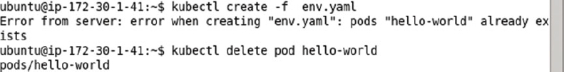

Run the kubectl create command to create a Pod from the definition file env.yaml.

kubectl create –f env.yaml

The output from the command is shown in [Figure 3-16](https://cdn2.percipio.com/1566228253.b35c854e5d30b7b50107168ae58de19049ee01b1/eod/books/113388/OEBPS/section-30.xhtml#ch3_fig16).

Figure 3-16: Creating a Pod from definition file in [Figure 3-14](https://cdn2.percipio.com/1566228253.b35c854e5d30b7b50107168ae58de19049ee01b1/eod/books/113388/OEBPS/section-30.xhtml#ch3_fig14)



The hello-world pod gets created as shown in [Figure 3-17](https://cdn2.percipio.com/1566228253.b35c854e5d30b7b50107168ae58de19049ee01b1/eod/books/113388/OEBPS/section-30.xhtml#ch3_fig17). Run the kubectl get command to list the pods.

Figure 3-17: The Pod terminates and its Status transitions to ExitCode:0 after the command has run

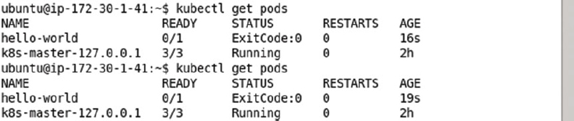

kubectl get pods

The hello-world pod gets listed as shown in [Figure 3-17](https://cdn2.percipio.com/1566228253.b35c854e5d30b7b50107168ae58de19049ee01b1/eod/books/113388/OEBPS/section-30.xhtml#ch3_fig17). The Pod transitions quickly to the READY value of 1/1 and subsequently 0/1. The 1/1 READY value is not shown in [Figure 3-17](https://cdn2.percipio.com/1566228253.b35c854e5d30b7b50107168ae58de19049ee01b1/eod/books/113388/OEBPS/section-30.xhtml#ch3_fig17) as it transitions quickly to 0/1. After the command has run the Pod terminates and the STATUS becomes ExitCode:0 as shown in [Figure 3-17](https://cdn2.percipio.com/1566228253.b35c854e5d30b7b50107168ae58de19049ee01b1/eod/books/113388/OEBPS/section-30.xhtml#ch3_fig17).

Subsequently invoke the following command to list the output generated by the Pod.

kubectl get logs

The message created with environment variables substitution from MESSAGE1 and MESSAGE2 gets listed as shown in [Figure 3-18](https://cdn2.percipio.com/1566228253.b35c854e5d30b7b50107168ae58de19049ee01b1/eod/books/113388/OEBPS/section-30.xhtml#ch3_fig18).

Figure 3-18: Outputting the Message Generated by Pod



## Summary

In this chapter we discussed the ENTRYPOINT and CMD instructions in a Docker image Dockerfile: instructions used to run the default command with the default parameters when the image is run in a Kubernetes Pod. We also discussed the Command and Args mappings in a Pod definition file that could be used to override the ENTRYPOINT and CMD instructions. We discussed various examples of overriding the default instructions for the "ubuntu" Docker image with "command" and "args" field mappings in a Pod definition file. We also demonstrated the use of environment variables in a Pod definition file. In the next chapter we shall discuss using MySQL Database with Kubernetes.

## Chapter 4: Using MySQL Database

**© Deepak Vohra 2016  
D. Vohra, Kubernetes Microservices with Docker, DOI 10.1007/978-1-4842-1907-2_4**

### Overview

MySQL database is the most commonly used open source database. The Docker image "mysql" could be used to create a Docker container running a MySQL database instance. Running Docker separately for a single MySQL instance or multiple instances lacks the features of scheduling multiple instances, scaling, and providing a service for external clients. In this chapter we shall discuss how the Kubernetes container cluster manager could be used to overcome all of those deficiencies.

**Setting the Environment**

The following software is required for this chapter.

* -Docker Engine (latest version)
* -Kubernetes Cluster Manager (version 1.01)
* -Kubectl (version 1.01)
* -Docker image "mysql" (latest version)

We have used an Amazon EC2 instance created from AMI Ubuntu Server 14-04 LTS (HVM), SSD Volume Type - ami-d05e75b8 to install the required software. The procedure to install Docker, Kubernetes, and Kubectl is discussed in [chapter 1](https://cdn2.percipio.com/1566228253.b35c854e5d30b7b50107168ae58de19049ee01b1/eod/books/113388/OEBPS/chapter-1-3.xhtml#ch001). Obtain the Public IP address of the Amazon EC2 instance as shown in [Figure 4-1](https://cdn2.percipio.com/1566228253.b35c854e5d30b7b50107168ae58de19049ee01b1/eod/books/113388/OEBPS/section-34.xhtml#ch4_fig1).

Figure 4-1: Obtaining the Public IP Address

Larger View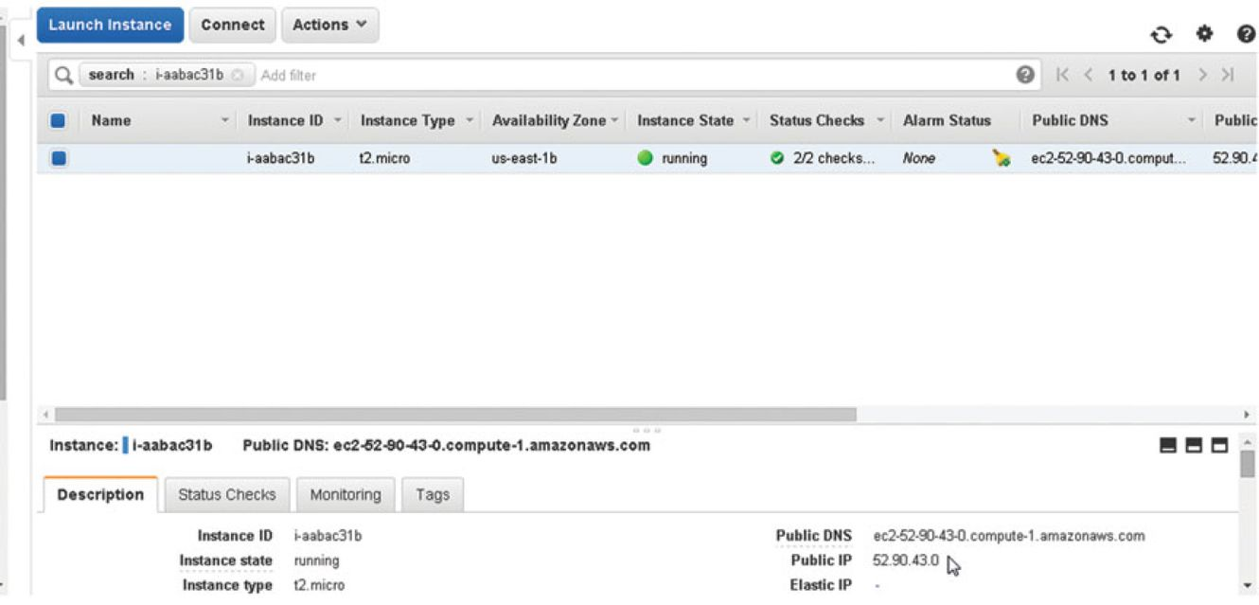

SSH log in to the Ubuntu instance using the Public IP Address, which would be different for different users.

sh -i "docker.pem" ubuntu@52.90.43.0

Start the Docker engine and verify its status.

sudo service docker start

sudo service docker status

The Docker Engine should be listed as "running" as shown in [Figure 4-2](https://cdn2.percipio.com/1566228253.b35c854e5d30b7b50107168ae58de19049ee01b1/eod/books/113388/OEBPS/section-34.xhtml#ch4_fig2).

Figure 4-2: Starting Docker and Verifying Its Status

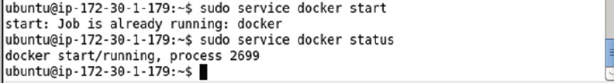

## Creating a Service

In this section we shall create a Kubernetes service using a definition file. We have used the YAML format for definition files, but JSON could be used just as well. Create a service definition file called mysql-service.yaml and copy the following listing to the file. Within the spec field mapping for the service the "selector" expression is set to app: "mysql-app," which translates to service selector app=mysql-app and which implies that the service routes traffic to Pods with the label app=mysql-app. If the selector expression is empty all Pods are selected. The port to expose the service is set to 3306 within the ports listing. And the service has a label app: "mysql-app". The kind field mapping must have value "Service."

apiVersion: v1

kind: Service

metadata:

name: "mysql"

labels:

app: "mysql-app"

spec:

ports:

# the port that this service should serve on

- port: 3306

# label keys and values that must match in order to receive traffic for this service

selector:

app: "mysql-app"

The service schema is available at <http://kubernetes.io/v1.1/docs/api-reference/v1/definitions.html#_v1_service>. Setting the selector field in the YAML definition file to app: "mysql-app" implies that all Pods with the YAML definition file label setting app: "mysql-app" are managed by the service. Create the service using the definition file with the kubectl create command.

kubectl create -f mysql-service.yaml

The mysql service gets created and the output is "services/mysql" as shown in [Figure 4-3](https://cdn2.percipio.com/1566228253.b35c854e5d30b7b50107168ae58de19049ee01b1/eod/books/113388/OEBPS/section-35.xhtml#ch4_fig3).

Figure 4-3: Creating a Service for MySQL Database



List the service using the following command.

kubectl get services

The mysql service gets listed as shown in [Figure 4-4](https://cdn2.percipio.com/1566228253.b35c854e5d30b7b50107168ae58de19049ee01b1/eod/books/113388/OEBPS/section-35.xhtml#ch4_fig4).

Figure 4-4: Listing the mysql Service

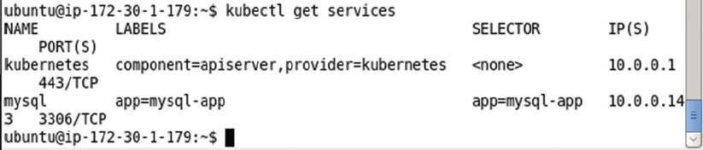

## Creating a Replication Controller

In this section we shall create a replication controller managed by the service created in the previous section. Create a replication controller definition file called mysql-rc.yaml and copy the following/next listing to the file. The kind field mapping must have value "ReplicationController." The replication controller has a label app: "mysql-app" in the metadata field mapping. If the labels are empty they are defaulted to the labels of the Pods the replication controller manages. The "spec" field mapping defines the replication controller and includes the "replicas" field mapping for the number of replicas to create. The replicas is set to 1 in the following/next listing. The default number of replicas is also 1. The spec includes a selector field mapping called app: "mysql-app," which selects all Pods with label app: "mysql-app" for the replication controller to manage and count toward the "replicas" setting. A Pod could have other labels in addition to the selector, but must include the selector expression/s of a replication controller to be managed by the replication controller. Similarly, a replication controller could be managing Pods not started with the replication controller definition file.

Labels and selector expression settings in YAML definition files are not used as such, but are translated to a label/selector by replacing the ':' with the '=' For example, service/replication controller selector setting app: "mysql-app" becomes selector app = mysql-app selector and label setting app: "mysql-app" becomes label app = mysql-app.

If a selector is not specified the labels on the template are used to match the Pods and count toward the "replicas" setting. The "template" field mapping defines a Pod managed by the replication controller. The spec field mapping within the template field specifies the behavior of the Pod. The "containers" field mapping within the "spec" field defines the collection/list of containers to create including the image, the environment variables if any, and the ports to use for each container.

We need to use an environment variable for the MySQL database replication controller. The Docker image "mysql" requires (is mandatory) the environment variable MYSQL_ROOT_PASSWORD to run a Docker container for MySQL database. The MYSQL_ROOT_PASSWORD variable sets the password for the root user. Environment variables are set with the "env" mapping within a containers field listing. An env mapping consists of a name mapping and a value mapping. The MYSQL_ROOT_PASSWORD environment variable is set as shown in the following listing. The "ports" field collection includes a containerPort mapping for port 3306. The indentations and hyphens in a YAML file must be well formatted and the following listing should be copied and syntax validated in the YAML Lint (<http://www.yamllint.com/>). The YAML lint only validates the syntax and does not validate if the Pod definition field conforms to the schema for a pod. The Pod schema is available at <http://kubernetes.io/v1.1/docs/api-reference/v1/definitions.html#_v1_podspec>.

---

apiVersion: v1

kind: ReplicationController

metadata:

labels:

app: "mysql-app"

spec:

replicas: 1

selector:

app: "mysql-app"

template:

metadata:

labels:

app: "mysql-app"

spec:

containers:

-

env:

-

name: "MYSQL_ROOT_PASSWORD"

value: "mysql"

image: "mysql"

name: "mysql"

ports:

-

containerPort: 3306

The mysql-rc.yaml definition file may be created in the vi editor and saved with the :wq command as shown in [Figure 4-5](https://cdn2.percipio.com/1566228253.b35c854e5d30b7b50107168ae58de19049ee01b1/eod/books/113388/OEBPS/section-36.xhtml#ch4_fig5).

Figure 4-5: Definition File for Replication Controller

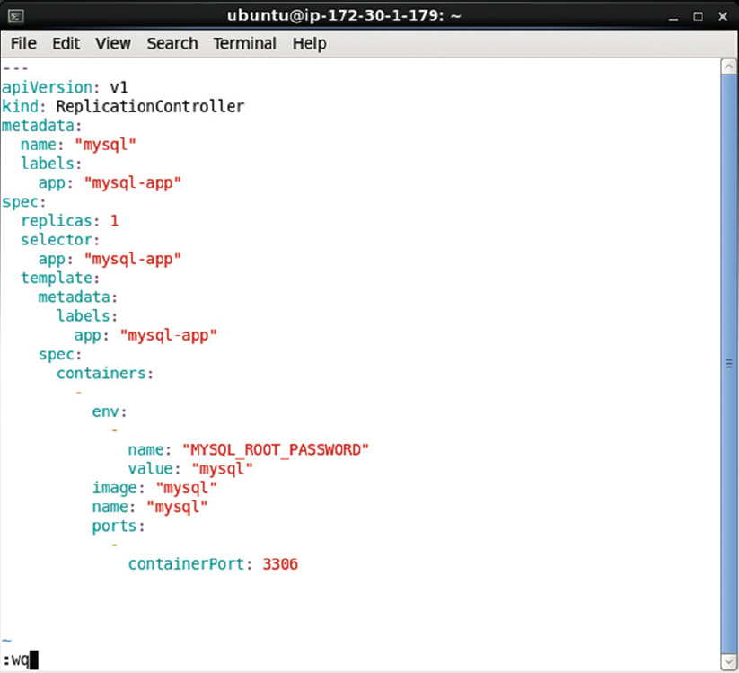

Create a replication controller from the service definition file with the kubectl create command.

kubectl create -f mysql-rc.yaml

As the output in [Figure 4-6](https://cdn2.percipio.com/1566228253.b35c854e5d30b7b50107168ae58de19049ee01b1/eod/books/113388/OEBPS/section-36.xhtml#ch4_fig6) indicates, the mysql replication controller gets created.

Figure 4-6: Creating a Replication Controller for MySQL Database



List the replication with the following command.

kubectl get rc

The mysql replication controller including the container name, image name, selector expression (app=mysql-app), and number of replicas get listed as shown in [Figure 4-7](https://cdn2.percipio.com/1566228253.b35c854e5d30b7b50107168ae58de19049ee01b1/eod/books/113388/OEBPS/section-36.xhtml#ch4_fig7).

Figure 4-7: Listing the MySQL Replication Controller



To describe the mysql replication controller run the following command.

kubectl describe rc mysql

The replication controller name, namespace, image, selector, labels, replicas, pod status, and events get listed as shown in [Figure 4-8](https://cdn2.percipio.com/1566228253.b35c854e5d30b7b50107168ae58de19049ee01b1/eod/books/113388/OEBPS/section-36.xhtml#ch4_fig8).

Figure 4-8: Describing the MySQL Replication Controller

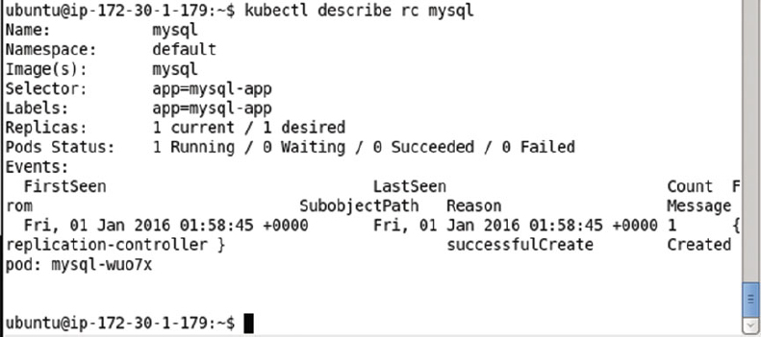

## Listing the Pods

The Pods created may be listed with the following command.

kubectl get pods

As shown in [Figure 4-9](https://cdn2.percipio.com/1566228253.b35c854e5d30b7b50107168ae58de19049ee01b1/eod/books/113388/OEBPS/section-37.xhtml#ch4_fig9) the 2 replicas created by the replication controller get listed. Initially the Pods may not be listed as READY 1/1. Run the preceding command after a few seconds, multiple times if required, to list all the Pods as ready.

Figure 4-9: Listing the Pod/s for MySQL Database

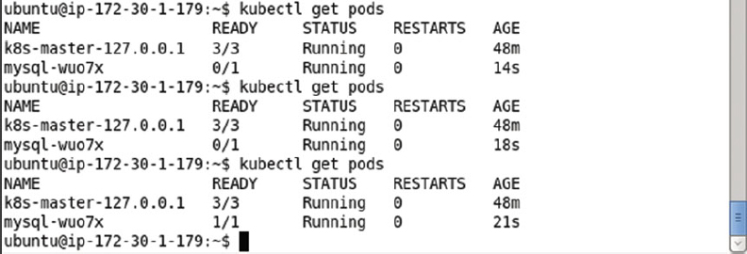

## Listing Logs

List the Pod logs for a pod: for example, the mysql-wuo7x pod, with the following command.

kubectl logs mysql-wuo7x

The Pod logs get listed as shown in [Figure 4-10](https://cdn2.percipio.com/1566228253.b35c854e5d30b7b50107168ae58de19049ee01b1/eod/books/113388/OEBPS/section-38.xhtml#ch4_fig10).

Figure 4-10: Listing the Logs generated by the Pod for MySQL Database

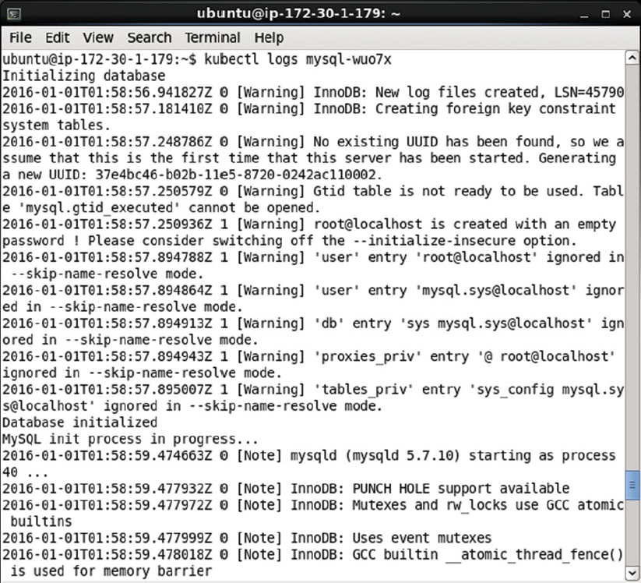

The MySQL Server is listed as started and "ready for connections" as shown in [Figure 4-11](https://cdn2.percipio.com/1566228253.b35c854e5d30b7b50107168ae58de19049ee01b1/eod/books/113388/OEBPS/section-38.xhtml#ch4_fig11).

Figure 4-11: Listing mysqld as Ready for Connections

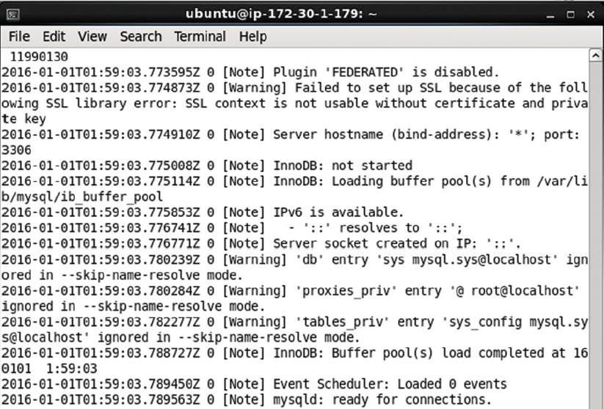

## Describing the Service

To describe the mysql service run the following command.

kubectl describe svc mysql

The service name, namespace, labels, selector, type, Ip, port and endpoints get listed. Because the number of replicas is set to 1 only one endpoint is listed as shown in [Figure 4-12](https://cdn2.percipio.com/1566228253.b35c854e5d30b7b50107168ae58de19049ee01b1/eod/books/113388/OEBPS/section-39.xhtml#ch4_fig12).

Figure 4-12: Describing the MySQL Service

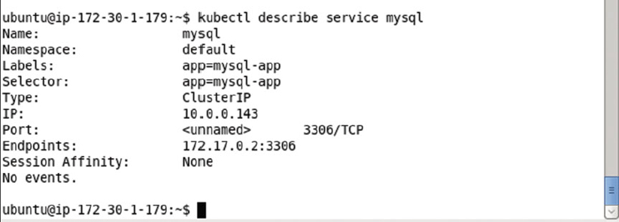

## Starting an Interactive Shell

Bash is the free version of the Bourne shell distributed with Linux and GNU operating systems (OS). For Docker images that have a Linux OS image as the base image as specified in the FROMinstruction in the Dockerfile, the software running in a Docker container may be accessed using the Bash shell. The "mysql" Docker image is based on the "debian" image and as a result supports access to software running in the Docker containers via a bash interactive shell.

Next, we shall start an interactive shell to start the MySQL CLI. But first we need to obtain the container id for one of the containers running MySQL. Run the following command to list the Docker containers.

sudo docker ps

The Docker container for the mysql image is shown listed in [Figure 4-13](https://cdn2.percipio.com/1566228253.b35c854e5d30b7b50107168ae58de19049ee01b1/eod/books/113388/OEBPS/section-40.xhtml#ch4_fig13).

Figure 4-13: Listing the Docker Containers

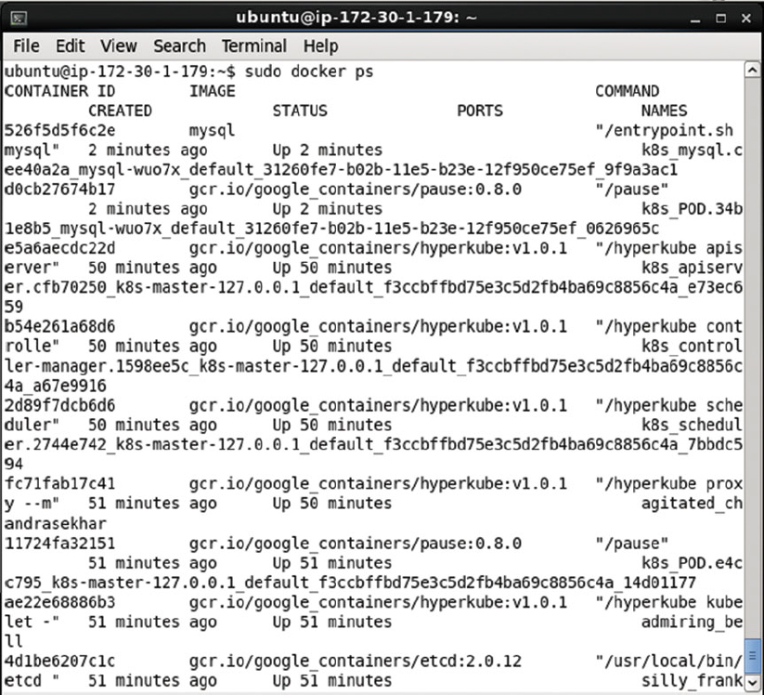

Using the Docker container id from the output from the preceding command, start an interactive shell.

sudo docker exec -it 526f5d5f6c2e bash

An interactive shell or tty gets started as shown in [Figure 4-14](https://cdn2.percipio.com/1566228253.b35c854e5d30b7b50107168ae58de19049ee01b1/eod/books/113388/OEBPS/section-40.xhtml#ch4_fig14).

Figure 4-14: Starting the Interactive Terminal



## Starting the MySQL CLI

Within the interactive shell run the following command to start the MySQL CLI as user root.

mysql –u root –p

When prompted with Password: set the password as the value of the environment variable MYSQL_ROOT_PASSWORD, which was set as "mysql" in the mysql-rc.yaml definition file. The MySQL CLI gets started as shown in [Figure 4-15](https://cdn2.percipio.com/1566228253.b35c854e5d30b7b50107168ae58de19049ee01b1/eod/books/113388/OEBPS/section-41.xhtml#ch4_fig15).

Figure 4-15: Starting the MySQL CLI Shell

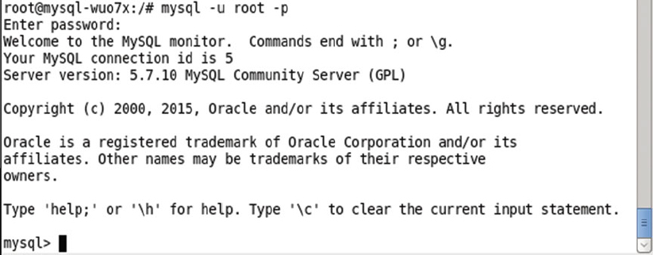

List the databases with the following command.

show databases;

The default databases shown in [Figure 4-16](https://cdn2.percipio.com/1566228253.b35c854e5d30b7b50107168ae58de19049ee01b1/eod/books/113388/OEBPS/section-41.xhtml#ch4_fig16) include the "mysql" database, which we shall use to create a database table. The other databases are system databases and should not be used for user tables.

Figure 4-16: Listing the Databases

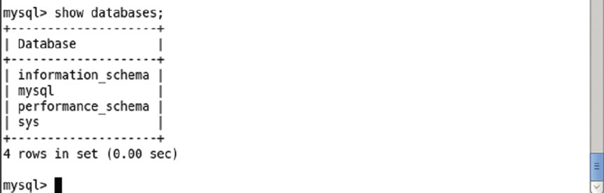

Set the database "mysql" as the current database with the following command.

use mysql

The database gets set as mysql as indicated by the "Database changed" output in [Figure 4-17](https://cdn2.percipio.com/1566228253.b35c854e5d30b7b50107168ae58de19049ee01b1/eod/books/113388/OEBPS/section-41.xhtml#ch4_fig17).

Figure 4-17: Setting the Database

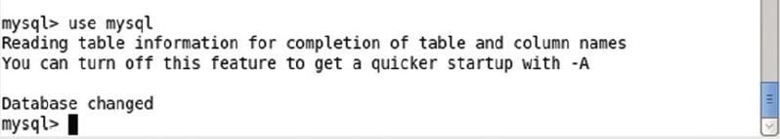

## Creating a Database Table

Next, create a database table called Catalog with the following SQL statement.

CREATE TABLE Catalog(CatalogId INTEGER PRIMARY KEY,Journal VARCHAR(25),

Publisher VARCHAR(25),Edition VARCHAR(25),Title VARCHAR(45),Author VARCHAR(25));

Add a row of data to the Catalog table with the following SQL statement.

INSERT INTO Catalog VALUES('1','Oracle Magazine','Oracle Publishing',

'November December 2013','Engineering as a Service','David A. Kelly');

The Catalog table gets created and a row of data gets added as shown in [Figure 4-18](https://cdn2.percipio.com/1566228253.b35c854e5d30b7b50107168ae58de19049ee01b1/eod/books/113388/OEBPS/section-42.xhtml#ch4_fig18).

Figure 4-18: Creating a MySQL Database Table

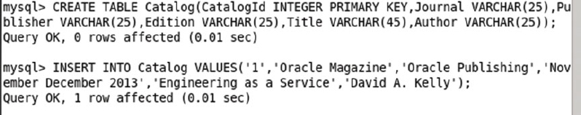

Subsequently run the following SQL statement to query the database table Catalog.

SELECT * FROM Catalog;

The single row of data added gets listed as shown in [Figure 4-19](https://cdn2.percipio.com/1566228253.b35c854e5d30b7b50107168ae58de19049ee01b1/eod/books/113388/OEBPS/section-42.xhtml#ch4_fig19).

Figure 4-19: Querying the Database Table

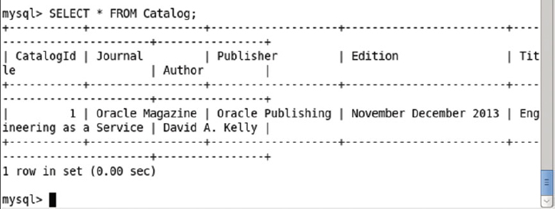

## Exiting the MySQL CLI and Interactive Shell

Exit the MySQL CLI with the "quit" command.

quit

Exit the interactive terminal with the "exit" command.

exit

The output from the preceding commands is shown in [Figure 4-20](https://cdn2.percipio.com/1566228253.b35c854e5d30b7b50107168ae58de19049ee01b1/eod/books/113388/OEBPS/section-43.xhtml#ch4_fig20).

Figure 4-20: Exiting the MySQL CLI Shell and Docker Container Interactive Shell

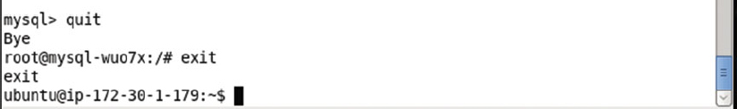

## Scaling the Replicas

One of the main benefits of Kubernetes is to be able to scale the number of MySQL instances in the cluster. Run the following kubectl scale command to scale the replicas from 1 to 4.

kubectl scale rc mysql --replicas=4

Subsequently run the following command to list the Pods.

kubectl get pods

The number of Pods for the MySQL database gets increased to 4 as shown in [Figure 4-21](https://cdn2.percipio.com/1566228253.b35c854e5d30b7b50107168ae58de19049ee01b1/eod/books/113388/OEBPS/section-44.xhtml#ch4_fig21). Some of the Pods may be listed as READY- > 0/1, which implies the Pod/s are not ready yet. When READY becomes 1/1 a Pod is ready to be accessed. The 0/1 value implies that 0 of the 1 Docker containers in the Pod are ready and similarly the 1/1 value implies that 1 of 1 containers is ready. The general syntax for the READY column value if all the n containers in the Pod are running is of the form n/n. The STATUS must be "Running" for a Pod to be considered available.

Figure 4-21: Scaling the Pod Replicas to Four

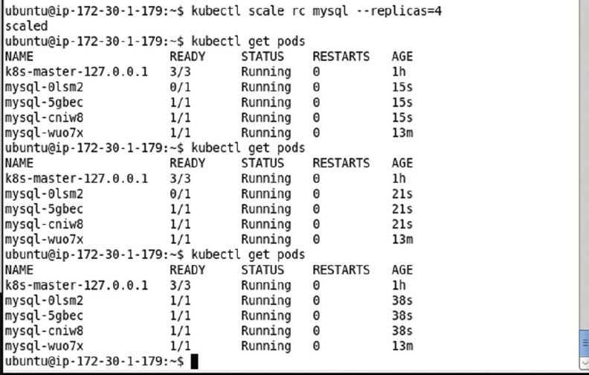

To describe the mysql service, run the following command.

kubectl describe svc mysql

The service description is the same as before except that the number of endpoints has increased to 4 as shown in [Figure 4-22](https://cdn2.percipio.com/1566228253.b35c854e5d30b7b50107168ae58de19049ee01b1/eod/books/113388/OEBPS/section-44.xhtml#ch4_fig22).

Figure 4-22: Describing the MySQL Service After Scaling the Pod Replicas

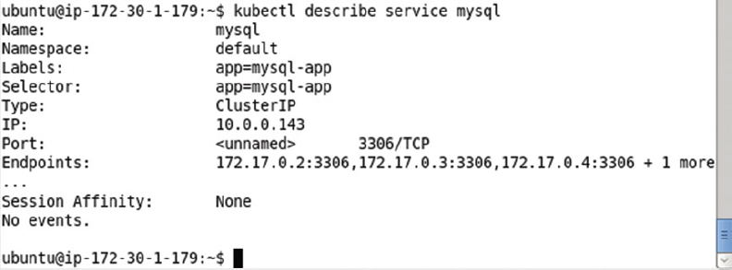

The command "scale" will also allow us to specify one or more preconditions for the scale actions needed. The following ([Table 4-1](https://cdn2.percipio.com/1566228253.b35c854e5d30b7b50107168ae58de19049ee01b1/eod/books/113388/OEBPS/section-44.xhtml#ch4_tab1)) preconditions are supported.

| **Table 4-1: Preconditions for the 'kubernetes scale' command** | |
| --- | --- |
| **Precondition** | **Description** |
| --current-replicas | The current number of replicas for the scale to be performed. |
| --resource-version | The resource version to match for the scale to be performed. |

## Deleting the Replication Controller

To delete the replication controller mysql, run the following command.

kubectl delete rc mysql

The replication controller gets deleted as shown in [Figure 4-23](https://cdn2.percipio.com/1566228253.b35c854e5d30b7b50107168ae58de19049ee01b1/eod/books/113388/OEBPS/section-45.xhtml#ch4_fig23). Whenever a kubectl command output to create or delete an artifact (a Pod, service or replication controller) is of the form artifact type/artifact name, it implies that the command has succeeded to create/delete the pod/service/replication controller.

Figure 4-23: Deleting the Replication Controller



Subsequently run the following command to get the replication controllers. The mysql rc does not get listed as shown in [Figure 4-24](https://cdn2.percipio.com/1566228253.b35c854e5d30b7b50107168ae58de19049ee01b1/eod/books/113388/OEBPS/section-45.xhtml#ch4_fig24).

kubectl get rc

Figure 4-24: Describing the Service after Deleting the Replication Controllers

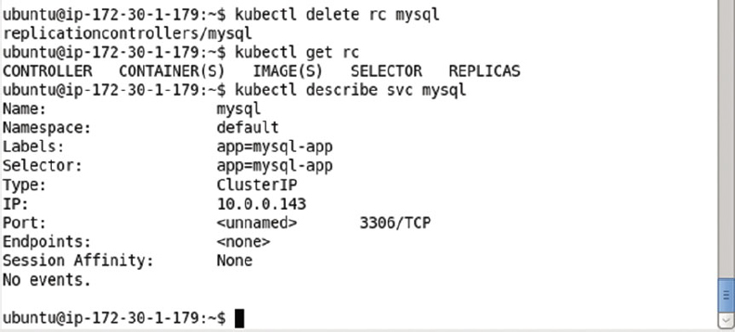

Describe the service mysql again with the following command.

kubectl describe svc mysql

No "Endpoints" get listed as shown in [Figure 4-24](https://cdn2.percipio.com/1566228253.b35c854e5d30b7b50107168ae58de19049ee01b1/eod/books/113388/OEBPS/section-45.xhtml#ch4_fig24) because all the Pods get deleted when the replication controller managing them is deleted.

## Summary

In this chapter we discussed orchestrating the MySQL database cluster using the Kubernetes cluster manager. We created a Kubernetes service to represent a MySQL-based Pod. The "mysql" Docker image is used to create a Pod. We used a replication controller to create replicas for MySQL base Pods. Initially the number of replicas is set to 1. We used a Docker container running a MySQL instance to start the MySQL CLI and create a database table. Subsequently, we scaled the number of replicas to 4 using the replication controller. When scaled, the number of replicas and therefore the number of MySQL instances becomes 4. The replication controller maintains the replication level through replica failure or replica shut down by a user. This chapter also demonstrates the use of environment variables. The MYSQL_ROOT_PASSWORD environment variable is required to run a container for the Docker image "mysql" and we set the MYSQL_ROOT_PASSWORDenvironment variable in the Pod spec in the replication controller. In the next chapter we shall discuss using another open source database, the PostgreSQL database.

## Chapter 5: Using PostgreSQL Database

**© Deepak Vohra 2016  
D. Vohra, Kubernetes Microservices with Docker, DOI 10.1007/978-1-4842-1907-2_5**

### Overview

PostgreSQL is an open source object-relational database. PostgreSQL is scalable both in terms of the quantity of data and number of concurrent users. PostgreSQL is supported in several of Apache Hadoop ecosystem projects such as Apache Sqoop and may be used for Apache Hive Metastore. PostgreSQL 9.5 offers several new features such as support for UPSERT, BRIN indexing, faster sorts, and the TABLESAMPLE clause for getting a statistical sample of a large table. In this chapter we shall discuss creating a PostgreSQL 9.5 cluster using the Kubernetes cluster manager. We shall discuss both the imperative approach and the declarative approach for creating and scaling a PostgreSQL cluster.

**Setting the Environment**

We have used the same type of Amazon EC2 instance in this chapter as in other chapters, an instance based on Ubuntu Server 14.04 LTS (HVM), SSD Volume Type - ami-d05e75b8 AMI. The following software is required for this chapter.

* -Docker Engine (latest version)
* -Kubernetes Cluster Manager (version 1.01)
* -Kubectl (version 1.01)
* -Docker Image "postgres" (latest version)

The procedure to install the required software, start Docker engine and Kubernetes cluster manager, is discussed in [chapter 1](https://cdn2.percipio.com/1566228253.b35c854e5d30b7b50107168ae58de19049ee01b1/eod/books/113388/OEBPS/chapter-1-3.xhtml#ch001). To install the software first we need to log in to the Amazon EC2 instance. Obtain the Public IP Address of the Amazon EC2 instance as shown in [Figure 5-1](https://cdn2.percipio.com/1566228253.b35c854e5d30b7b50107168ae58de19049ee01b1/eod/books/113388/OEBPS/section-48.xhtml#ch5_fig1).

Figure 5-1: Obtaining the Public IP Address

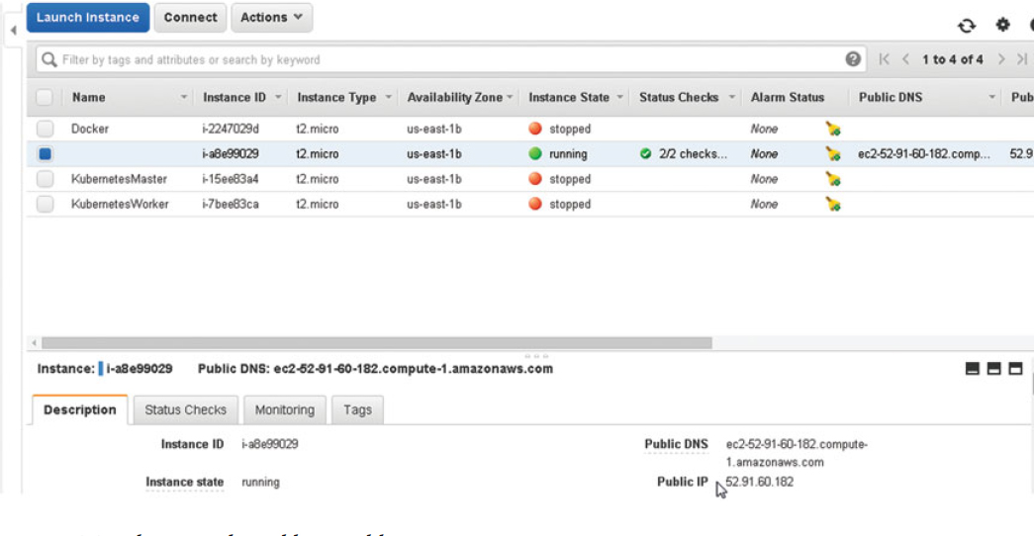

SSH Login to the Ubuntu instance using the Public IP Address.

ssh -i "docker.pem" ubuntu@52.91.60.182

Start the Docker engine and verify its status.

sudo service docker start

sudo service docker status

Docker should be indicated as "running" as shown in [Figure 5-2](https://cdn2.percipio.com/1566228253.b35c854e5d30b7b50107168ae58de19049ee01b1/eod/books/113388/OEBPS/section-48.xhtml#ch5_fig2).

Figure 5-2: Starting Docker

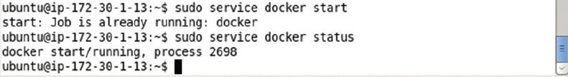

List the services with the following command.

kubectl get services

The kubernetes service should get listed as shown in [Figure 5-3](https://cdn2.percipio.com/1566228253.b35c854e5d30b7b50107168ae58de19049ee01b1/eod/books/113388/OEBPS/section-48.xhtml#ch5_fig3).

Figure 5-3: Listing the Kubernetes Services

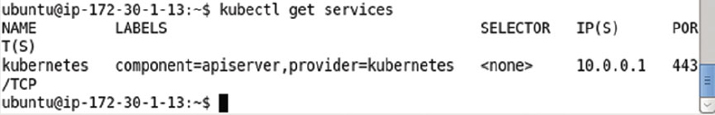

## Creating a PostgreSQL Cluster Imperatively

Using a declarative approach with definition files offers finer control over the service and replication controller. But a replication controller and service could also be created on the command line with kubectl commands. In the following subsections we shall create a replication controller and a service.

### Creating a Replication Controller

To create a replication controller called postgres for image "postgres" with number of replicas as 2 and Post as 5432 run the following command.

kubectl run postgres --image=postgres --replicas=2 --port=5432

The postgres replication controller with 2 replicas of Pod with image postgres and selector expression run=postgres gets created as shown in [Figure 5-25](https://cdn2.percipio.com/1566228253.b35c854e5d30b7b50107168ae58de19049ee01b1/eod/books/113388/OEBPS/section-50.xhtml#ch5_fig25).

Figure 5-25: Creating a Replication Controller Imperatively

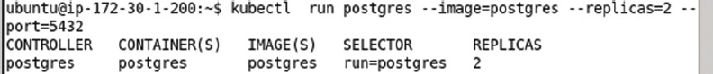

List the replication controllers with the following command.

kubectl get rc

The postgres replication controller gets listed as shown in [Figure 5-26](https://cdn2.percipio.com/1566228253.b35c854e5d30b7b50107168ae58de19049ee01b1/eod/books/113388/OEBPS/section-50.xhtml#ch5_fig26).

Figure 5-26: Listing the Replication Controllers



### Getting the Pods

To list the Pods managed by the replication controller run the following command.

kubectl get pods

The two Pods get listed as shown in [Figure 5-27](https://cdn2.percipio.com/1566228253.b35c854e5d30b7b50107168ae58de19049ee01b1/eod/books/113388/OEBPS/section-50.xhtml#ch5_fig27). Initially some of the Pods could be listed not Ready as indicated by the 0/1 READY column value. Run the preceding command again to list the Pods as ready with READY column value as 1/1.

Figure 5-27: Listing the Pods

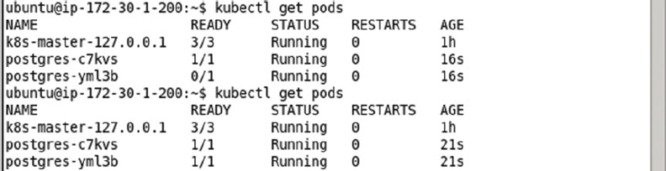

### Creating a Service

To create a service we need to run the kubectl expose command. Initially only the kubernetes service is running. To demonstrate, run the following command.

kubectl get services

As shown in [Figure 5-28](https://cdn2.percipio.com/1566228253.b35c854e5d30b7b50107168ae58de19049ee01b1/eod/books/113388/OEBPS/section-50.xhtml#ch5_fig28) only the kubernetes service is listed.

Figure 5-28: Listing the "kubernetes" Service

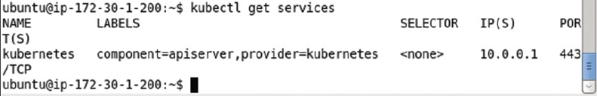

To create a service for the replication controller "postgres" run the following command in which the –port parameter specifies the port at which the service is exposed. The service type is set as LoadBalancer.

kubectl expose rc postgres --port=5432 --type=LoadBalancer

Subsequently list the services.

kubectl get services

The postgres service gets listed as shown in [Figure 5-29](https://cdn2.percipio.com/1566228253.b35c854e5d30b7b50107168ae58de19049ee01b1/eod/books/113388/OEBPS/section-50.xhtml#ch5_fig29).

Figure 5-29: Creating a Service exposed at Port 5432

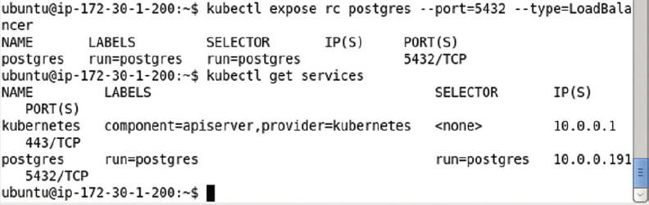

### Creating a Database Table

The procedure to create a database table is the same as discussed previously for the declarative section and is discussed only briefly in this section. List the Docker containers with the following command.

sudo docker ps

Two of the Docker containers are listed with image as postgres in the IMAGE column as shown in [Figure 5-30](https://cdn2.percipio.com/1566228253.b35c854e5d30b7b50107168ae58de19049ee01b1/eod/books/113388/OEBPS/section-50.xhtml#ch5_fig30). Copy the container id for one of these columns from the CONTAINER ID column.

Figure 5-30: Listing the Docker Containers

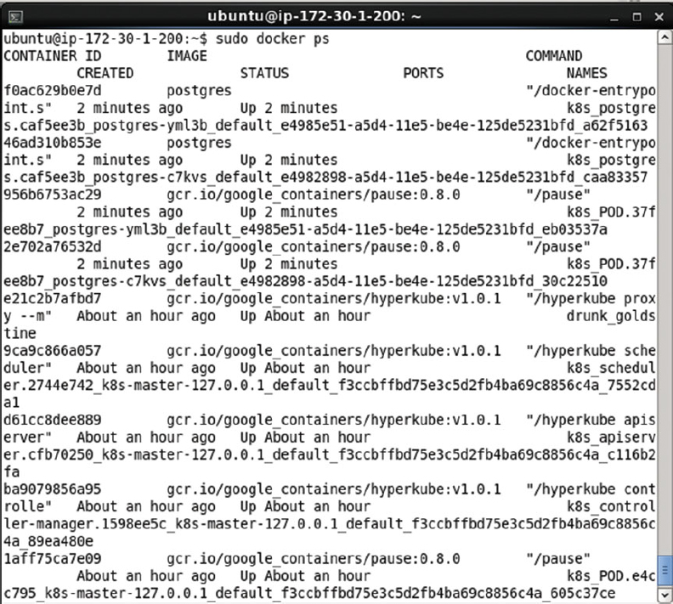

Start the interactive shell with the following command.

sudo docker exec -it af0ac629b0e7d bash

The interactive terminal gets started as shown in [Figure 5-31](https://cdn2.percipio.com/1566228253.b35c854e5d30b7b50107168ae58de19049ee01b1/eod/books/113388/OEBPS/section-50.xhtml#ch5_fig31).

Figure 5-31: Starting the TTY



Set the user as postgres.

su –l postgres

Start the psql command line shell.

psql postgres

The psql shell is shown in [Figure 5-32](https://cdn2.percipio.com/1566228253.b35c854e5d30b7b50107168ae58de19049ee01b1/eod/books/113388/OEBPS/section-50.xhtml#ch5_fig32).

Figure 5-32: Starting the psql Shell

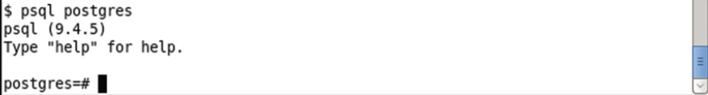

Run the following SQL statements to create a database table called wlslog and add data to the table.

CREATE TABLE wlslog(time_stamp VARCHAR(255) PRIMARY KEY,category VARCHAR(255),type

VARCHAR(255),servername VARCHAR(255),code VARCHAR(255),msg VARCHAR(255));

INSERT INTO wlslog(time_stamp,category,type,servername,code,msg) VALUES('Apr-8-2014-7:

06:16-PM-PDT','Notice','WebLogicServer','AdminServer','BEA-000365','Server state changed

to STANDBY');

INSERT INTO wlslog(time_stamp,category,type,servername,code,msg) VALUES('Apr-8-2014-7:

06:17-PM-PDT','Notice','WebLogicServer','AdminServer','BEA-000365','Server state changed

to STARTING');

INSERT INTO wlslog(time_stamp,category,type,servername,code,msg) VALUES('Apr-8-2014-7:

06:18-PM-PDT','Notice','WebLogicServer','AdminServer','BEA-000360','Server started in

RUNNING mode');

The database table wlslog gets created as shown in [Figure 5-33](https://cdn2.percipio.com/1566228253.b35c854e5d30b7b50107168ae58de19049ee01b1/eod/books/113388/OEBPS/section-50.xhtml#ch5_fig33).

Figure 5-33: Creating a Database Table

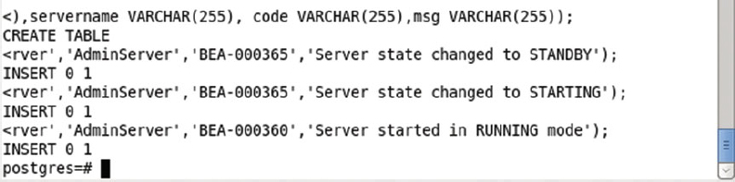

Run the following SQL statement to query the wlslog table.

SELECT * FROM wlslog;

The three rows of data added get listed as shown in [Figure 5-34](https://cdn2.percipio.com/1566228253.b35c854e5d30b7b50107168ae58de19049ee01b1/eod/books/113388/OEBPS/section-50.xhtml#ch5_fig34).

Figure 5-34: Querying the wlslog Database Table

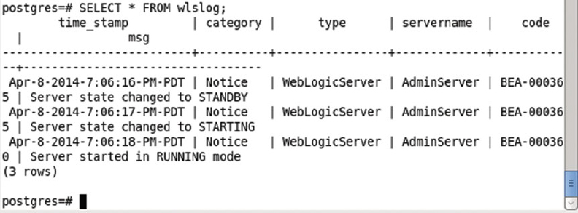

To quit the psql shell and the interactive shell for the Docker container running PostgreSQL, run the following commands.

\q

**exit**

The psql shell and the tty get exited as shown in [Figure 5-35](https://cdn2.percipio.com/1566228253.b35c854e5d30b7b50107168ae58de19049ee01b1/eod/books/113388/OEBPS/section-50.xhtml#ch5_fig35).

Figure 5-35: Exiting the Shells

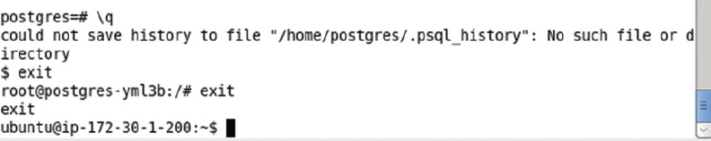

### Scaling the PostgreSQL Cluster

When we created the cluster initially we set the replicas to 2. List the pods as follows.

kubectl get pods

Only two Pods get listed as shown in [Figure 5-36](https://cdn2.percipio.com/1566228253.b35c854e5d30b7b50107168ae58de19049ee01b1/eod/books/113388/OEBPS/section-50.xhtml#ch5_fig36).

Figure 5-36: Listing the Pods

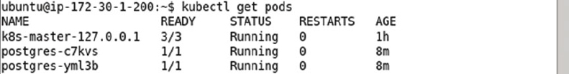

Scale the cluster to 4 replicas with the following command.

kubectl scale rc postgres --replicas=4

An output of "scaled" as shown in [Figure 5-37](https://cdn2.percipio.com/1566228253.b35c854e5d30b7b50107168ae58de19049ee01b1/eod/books/113388/OEBPS/section-50.xhtml#ch5_fig37) indicates that the cluster has been scaled.

Figure 5-37: Scaling the Pod Replicas to 4



Subsequently list the Pods.

kubectl get pods

The preceding command may have to be run multiple times to list all the Pods as "Running" and in READY state 1/1 as shown in [Figure 5-38](https://cdn2.percipio.com/1566228253.b35c854e5d30b7b50107168ae58de19049ee01b1/eod/books/113388/OEBPS/section-50.xhtml#ch5_fig38).

Figure 5-38: Listing the Pods in various states of starting

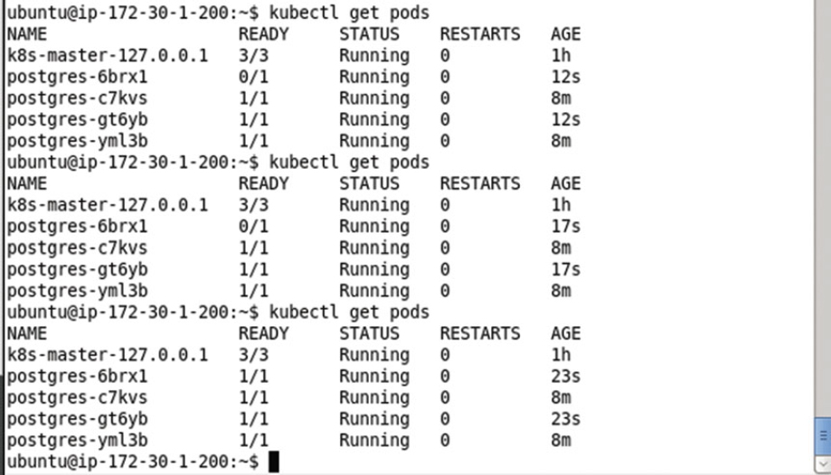

### Deleting the Replication Controller

To delete the replication controller run the following command.

kubectl delete rc postgres

List the Pods subsequent to deleting the rc.

kubectl get pods

List the services.

kubectl get services

The postgres replication controller gets deleted and does not get listed subsequently as shown in [Figure 5-39](https://cdn2.percipio.com/1566228253.b35c854e5d30b7b50107168ae58de19049ee01b1/eod/books/113388/OEBPS/section-50.xhtml#ch5_fig39). The postgres service still gets listed also shown in [Figure 5-39](https://cdn2.percipio.com/1566228253.b35c854e5d30b7b50107168ae58de19049ee01b1/eod/books/113388/OEBPS/section-50.xhtml#ch5_fig39).

Figure 5-39: Deleting the Replication Controller

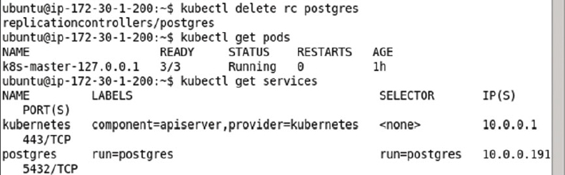

### Stopping the Service

To stop the service run the following command.

kubectl stop service postgres

The postgres service gets stopped as shown in [Figure 5-40](https://cdn2.percipio.com/1566228253.b35c854e5d30b7b50107168ae58de19049ee01b1/eod/books/113388/OEBPS/section-50.xhtml#ch5_fig40). Subsequently run the following command.

kubectl get services

The postgres service does not get listed as shown in [Figure 5-40](https://cdn2.percipio.com/1566228253.b35c854e5d30b7b50107168ae58de19049ee01b1/eod/books/113388/OEBPS/section-50.xhtml#ch5_fig40) also.

Figure 5-40: Stopping the Service

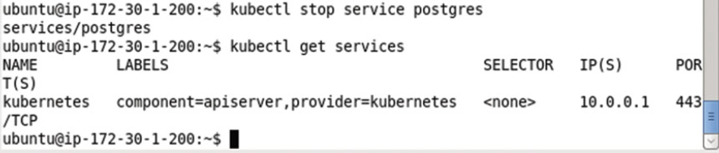

## Summary

In this chapter we used the Kubernetes cluster manager to start and manage a PostgreSQL server cluster. We demonstrated creating a cluster both imperatively on the command line and declaratively using definition files. We scaled the cluster using a replication controller and exposed a service for the cluster using a Kubernetes service. In the next chapter we shall discuss creating and managing an Oracle Database cluster.

## Chapter 6: Using Oracle Database

**© Deepak Vohra 2016  
D. Vohra, Kubernetes Microservices with Docker, DOI 10.1007/978-1-4842-1907-2_6**

### Overview

Oracle Database is the most commonly used relational database (RDBMS). Installing and configuring Oracle Database would usually involve downloading the software, setting the kernel parameters, installing and configuring the software, all of which is quite involved. Using Docker containers coordinated with Kubernetes makes the task of installing, configuring, and orchestrating a Oracle Database cluster much easier. Oracle Database cluster consisting of multiple instances could benefit from the schedulability, scalability, distributedness, and failover features of the Kubernetes container cluster manager. In this chapter we shall install Oracle Database using a Docker image for the database. We shall create multiple replicas of the database Pod using a replication controller and expose the database as a service.

**Setting the Environment**

The following software is required for this chapter.

* -Docker Engine (latest version)
* -Kubernetes (version 1.01)
* -Kubectl (version 1.01)
* -Docker Image for Oracle Database (Oracle Database XE 11g)

If not already installed, install Docker Engine, Kubernetes, and Kubectl as discussed in [Chapter 1](https://cdn2.percipio.com/1566228253.b35c854e5d30b7b50107168ae58de19049ee01b1/eod/books/113388/OEBPS/chapter-1-3.xhtml#ch001). SSH login to the Ubuntu instance on Amazon EC2 using the Public IP Address of the EC2 instance.

ssh -i "docker.pem" ubuntu@52.90.115.30

Start the Docker instance and verify its status with the following commands.

sudo service docker start

sudo service docker status

Docker is indicated as running in [Figure 6-1](https://cdn2.percipio.com/1566228253.b35c854e5d30b7b50107168ae58de19049ee01b1/eod/books/113388/OEBPS/section-53.xhtml#ch6_fig1).

Figure 6-1: Starting Docker and verifying its Status

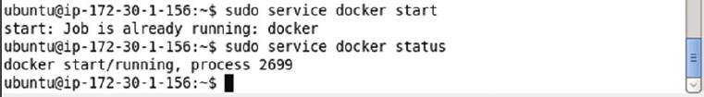

List the services running.

kubectl get services

Only the kubernetes service is listed as running in [Figure 6-2](https://cdn2.percipio.com/1566228253.b35c854e5d30b7b50107168ae58de19049ee01b1/eod/books/113388/OEBPS/section-53.xhtml#ch6_fig2).

Figure 6-2: Listing the Kubernetes Service

